|  |
| --- |
| **Eqic dIES & moulds engineers pvt. ltd.** |
| INTERNSHIP REPORT |
| By |
| S. CHETANA REDDY 19071A0348  P. SIDDARDTH 19071A0339  V. SIMON PRASHANTH 19071A0358  D. TARUN KUMAR 19071A0314  G. SAI SRI HARSHA 19BME0101 |
|  |
|  |

|  |
| --- |
| http://www.vnrvjiet.ac.in/logo11.png |

**EQIC DIES AND MOULDS ENGINEERS PVT. LTD.**

**INTERNSHIP**​**PROGRAM**

A REPORT

ON

INDUSTRIAL INTERNSHIP

BY

S. CHETANA REDDY 19071A0348

P. SIDDARDTH VARMA 19071A0339

V. SIMON PRASHANTH 19071A0358

D. THARUN KUMAR 19071A0314

G. SAI SRI HARSHA 19BME0101

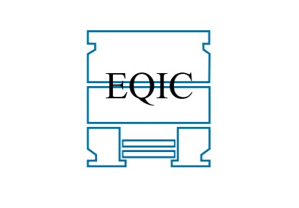

**Industry:** EQIC Dies and Moulds PVT. LTD.

**Centre:** Jeedimetla

**Duration:** 3 months

**Acknowledgement**

It is always a pleasure to remind the fine people in the Workshop for their sincere guidance to receive and uphold our practical as well as theoretical skills in engineering.

I am extremely thankful and indebted to the numerous Eqic Dies engineers, who provided vital information about the functioning of their respective departments thus helping me to gain an overall idea of the working of the organization.

I am highly thankful to Mr.Subba Rao sir and Mr. Raju sir for giving us the opportunity to pursue internship in this company and Mr. Nitin sir and

Mr.Akhil sir, our project mentors for their bold and frank reviews regarding our work at EQIC Dies.

I would like to thank all departmental in charges and work men for the positive attitude they showed for my work, always allowing me to question them and giving prompt replies for my uncertainties.

**Table of Contents**

|  |  |  |
| --- | --- | --- |
| S.No. | Topic | Page No. |
| 1. | Company Introduction | 5-7 |
| 2. | Process Epitome | 8-17 |
| 3. | Design | 18-35 |
| 4. | Die Manufacturing Process | 36-44 |
| 5. | Assembly of Die | 45-57 |
| 6. | Component Production | 58-77 |

**EQIC DIES AND MOULDS ENGINEERS PVT. LTD.**

**INTERNSHIP**​ **REPORT**

**ABOUT THE COMPANY**:

Established in 1988.​

It is the leading manufacturer of high quality and reliable dies and moulds used for die casting. It manufactures dies for companies in various industries like Aerospace, Power, Automobile etc.​

EQIC undertakes Design & Manufacture of cold chamber and also hot chamber Die casting dies for casting of Aluminium and Zinc respectively.​

It has the capability to build Pressure Die-Casting Dies from 100 tons to 1200 tons die casting press capacity.

**Vision of the company:**

**VISION:​**

To be a global source for precision engineering.​

**MISSION: ​**

* To be preferred partner of Automobile & Aerospace Industry for reliable TOOLING and Products.
* Innovation through employee motivation and empowerment.​
* Customer delight through timely delivery, improved quality

**Objectives:**

* The core objective of this internship was to observe the design and manufacturing casting die.
* The particular die that has work order number 10521.
* The manufacturing process undergoes various steps and is carried out in dies and moulds division of EQIC.
* The project task given by the company to us is to follow the manufacturing process.
* Die and coordinate various processes involved.

**Die Casting:**

Die casting is a metal casting process that is characterized by forcing molten metal under high pressure into a mould cavity.​

The mould cavity is created using two hardened tool steel dies which have been machined into shape.​

Depending on the type of metal being cast, a hot- or cold-chamber machine is used.​

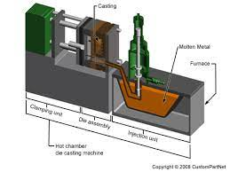

**Dies:**

A die is a machined metal block in which the molten metal is forced into the Mould with high pressure during the process of die casting.​

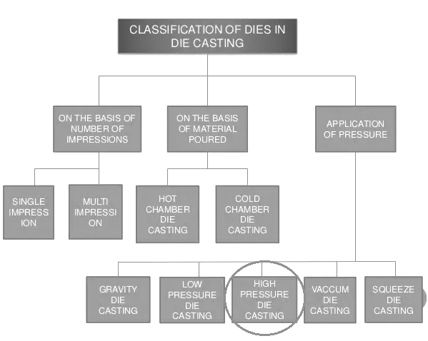

**HPDC (High Pressure Die Casting)**

High-pressure die casting is a process wherein molten metal is forced, under pressure, into a sealed mould cavity. It is held in place by a powerful compressive power (true die installed in a hydraulic machine) until the metal solidifies.

Following solidification, the die is released, opened and the metal is released.

Following removal, the mould cavity is resealed for the next cycle.

Molten metal injection into the mould cavity occurs in a fraction of a second (usually under 100 MS). Once die cavity is filled, extremely high pressure is applied (often over 1000 bar) into a molten metal true injection plunger. This phase is called intensification.

This pressure compresses out any gases trapped in the metal (during extremely fast and turbulent cavity filling) and feeds more metal into the mould to partially compensate for the shrinkage in the metal whilst it is solidifying.

In addition to traditional high-pressure die casting methods, over recent years there have been a number of improvements in the process. For example: Vacuum die casting, Semi-solid casting, Squeeze casting, etc.

High pressure die-casting:

In order to inject molten metal into the mould, two different systems may be used:

* Hot chamber system
* Cold chamber system

**The hot chamber system:**

The hot chamber system is used with metals such as zinc, magnesium and lead.

The injection system for a hot chamber machine is immersed in molten metal from the blast furnace. When the piston pumps, it forces metal along the nozzle and into the die.

**The cold chamber system:**

The cold chamber system is used for metals which melt at high temperatures, such as aluminum, copper and magnesium.

Magnesium parts can be produced by using either system, although generally speaking small parts are made in hot chamber systems, whilst large parts in cold chamber systems, as hot chamber machines have limited dimensions.

In this system higher pressure is used compared to the hot chamber system. The production rate of a hot chamber machine is higher than that of a cold chamber since less time is required for the pouring process.

The cold chamber system also uses two injections systems in the process:

* Horizontal injection
* Vertical injection

In this system, the molten metal is poured, either manually or automatically, into an opening leading to a channel feeding the cold chamber.

A piston which is hydraulically activated moves down this steel channel, blocking light and pushing the metal into the mould at high speed and pressure.

Following solidification of the flow, the piston is pulled back, and the mould opened, the flow is expelled and the system is ready to be activated again.

**Advantages of high pressure die casting:**

The advantages of high pressure die casting include higher production speeds when compared to the flow pouring under the effect of gravity.

Furthermore, the ability to produce flows of specific dimensions notably reduces processing operations.

The fusions have a good surface finish, which is a basic requisite for plating, and reduced thickness of the plate walls is made possible by reducing the overall weight of the fusion.

The mounds are durable, thus reducing unit cost prices and more complex parts can be manufactured, thus decreasing the number of components requested each time.

High-pressure die casting is used to create everything from engine blocks to aerospace components and even heavy-duty fasteners. While there are different ways to perform it, **most high-pressure die casting processes consist of the four following steps:**

**1) Preparing the Mold:**

The first step of high-pressure die casting is mold preparation. During this initial step, the manufacturing company applies a lubricant to the interior walls of the mold. This is important because the lubricant regulates the mold’s temperature while also creating a film between the molten metal and the mold, thereby allowing for easier removal of the casting.

**2) Injection**

After preparing the die mold, the manufacturing company injects it with molten metal. The mold must be completely closed and sealed during this step. Otherwise, it won’t be able to “accept” the highly pressurized molten metal. Depending on the specific application, the molten metal may be injected into the mold at a pressure of between 1,500 to 25,000 pounds per square inch (PSI). The mold maintains this pressure until the molten metal has cooled and solidified.

**3) Cavity Ejection**

Next, the manufacturing company ejects the newly made cavity from the mold. The mold itself typically features ejector pins that, when engaged, release the cavity. Of course, the cavity must be solid for it to eject. If the raw metal is still liquid, the manufacturing company must wait for it to cool before it can eject the cavity from the mold.

**4) Shakeout**

The fourth and final step of high-pressure die casting is shakeout. During this step, the manufacturing company separates any scrap metal from the newly created cavity. It’s not uncommon for high-pressure die casting to produce excess scrap metal. In other words, not all of the molten metal is used to create the casting. Some remains stuck inside the mold. As a result, the scrap metal must be removed before the mold can be reused.

**The basic functional parts in a HPDC die or injection molding mould are:**

Cavity and Cores (which give the shape to the casting or molding):

Core: It is male part which form internal shape of molding

Cavity: It is the female part which form external shape of molding

Runner system: It leads the molten raw material from the machine injection/shot system to the cavities

Core moving mechanisms: It will move the movable cores in the beginning of the machine cycle and out along with the mould/die opening.

Ejecting mechanism: It removes the part from the cavity together with the machine ejection system.

Cooling/tempering channels: It keeps the thermal balance during moulding or casting operations.

The mould/die functional parts act together with the casting/moulding machine. In the machine there are parts for dosing the raw material into the mould/die, parts for producing the core moving forces (electrical, hydraulic or pneumatic), parts for producing the forces for ejection (electrical or hydraulic) and parts for circulating the cooling liquid inside the mould cooling tempering channels.

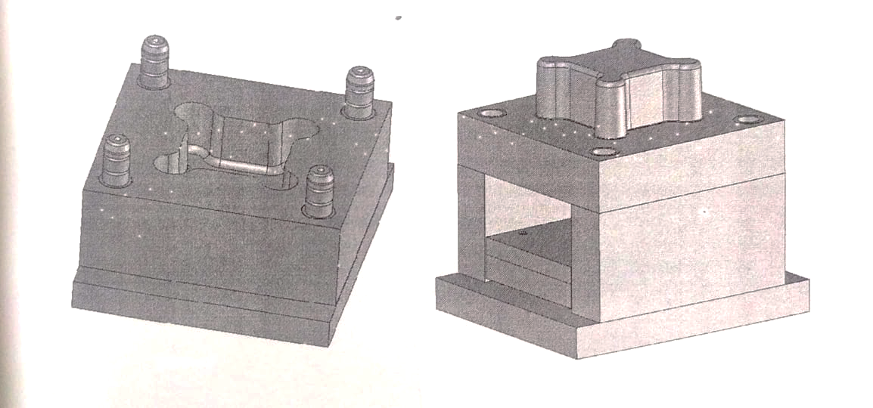The space inside the mould in which the part is shaped is called a mould cavity. The surface between the fixed and movable halves is called a parting surface. As the first choice the parting surface should be planar. Only if it is absolutely necessary to make a stepped or shaped parting surface, this option could be taken into consideration. The two mould halves need to fit tightly together.

Image 2: Left: Mould fixed side with the cavity. The space, inside which the part is shaped, is also called a cavity. Right: Mould movable side with a core. The surface between these mould halves is called a parting surface.

**DRAFT ANGLE-**

All cores are prepared with angled vertical surfaces. None of the vertical surfaces is perpendicular to the parting surface. The angle is called a draft. All moulded part or high pressure die casting vertical surfaces must be prepared with a draft angle. Otherwise, it is not possible to eject the casting out of the mould.

A core is any extension in the mould. There are two types of cores: fixed and moving. Note that an extension in the mould is a recession or hole in the part. The fixed cores can be either separated parts or just machined extensions in the mould cavity plates (See image next page.). The part fastens around a core, because all injection mould able plastics and high pressure dies castable metals shrink during cooling. It is practical to place the part into the mould so that as many cores as possible are located in the moving side and as much of the cavity as possible in the fixed side like in the image above. This arrangement fastens the molded part to the moving

Side and makes it possible to eject it in the right time.

There are three basic structures:

A slide mechanism, a pulling cylinder and a string loaded pulling mechanism.

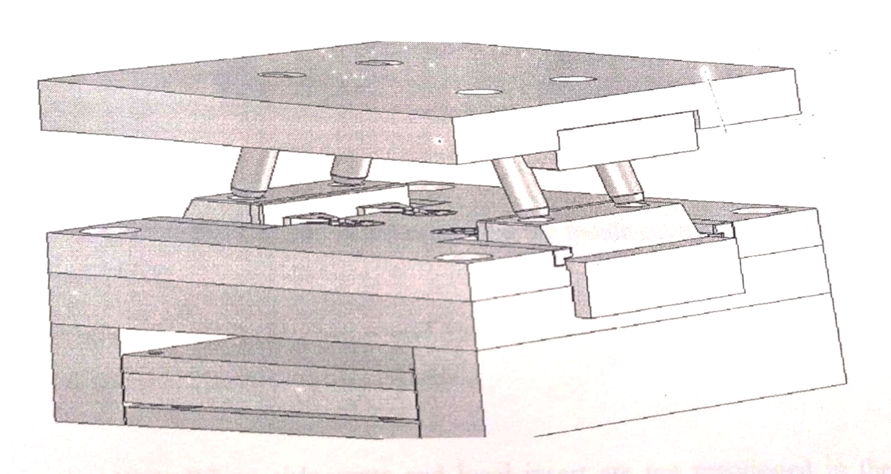

Image 3. A sliding core mechanism. The basic components in this system are: angle pins, slides, guiding rails and slide locking components. The idea is to move cores out of the part during the mould opening movement. After the cores are removed, the ejection is possible.

The part is removed from the mould cavity with standard mould parts called ejectors. Ejectors are round, flat or cylinder-shaped pins with a collar on one end. The ejectors are fastened with this collar between the ejector seat plates, ejector base plate and ejector retaining plate. (See image 2.) The ejector seat is guided with strong ejector pins, ejector returning pins or with special guiding components.

The ejector seat is fastened to the injection moulding or high pressure die casting machine ejection system. A high pressure die casting mould is fastened with four ejection bars. An injection moulding mould is typically fastened with one ejector pushing component which is placed into the middle of the ejector seat plates. Typically, the high pressure die casting die ejection set needs only a light guiding system or no guiding at all.

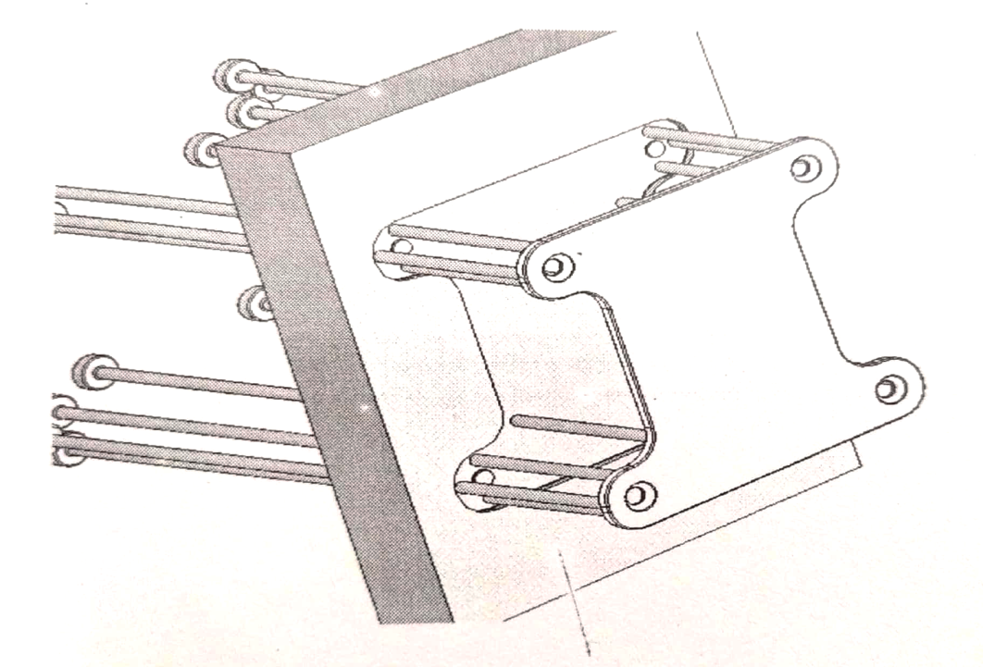

Image. Ejector pins. The part is removed from the mould cavity with round, flat or cylinder-shaped ejectors

Some part like sliders, side cores and local insert are not mentioned in the above schematic diagram, these get incorporated into the BOM (Bill of material) which is the list of all materials used for manufacturing of the die.

**Manufacturing Process**

Now, after the discussion and understanding about the process of High Pressure Die Casting in detail,

The following steps are involved in the entire manufacturing process of a die:

* Design
* Casting
* Assembly

After the die is manufactured, for the production of the component, the die is sent to the Production unit, where the component is manufactured and further steps are taken.

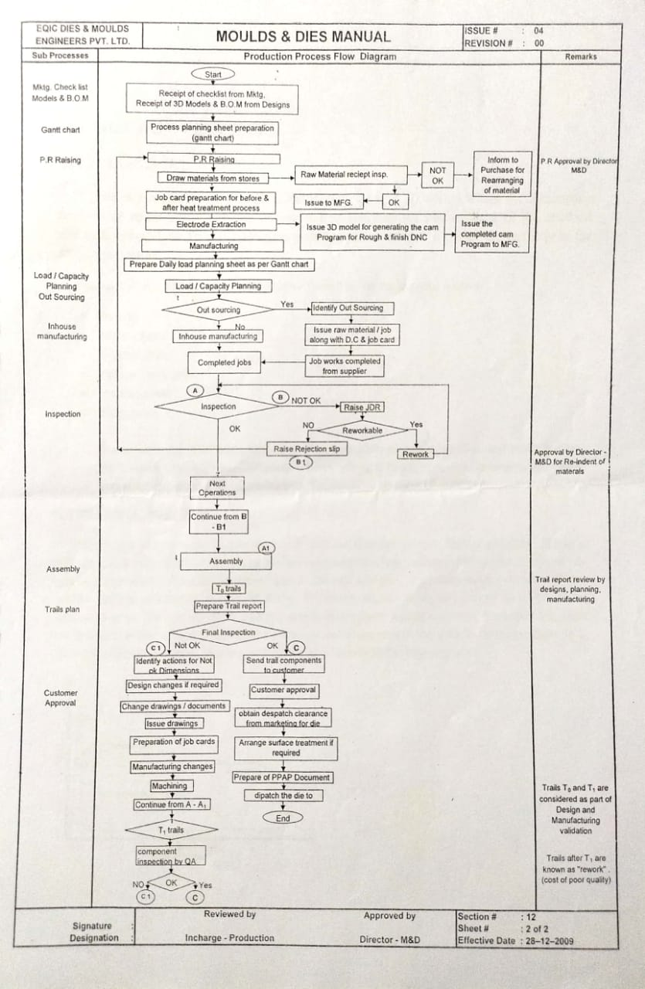

**DESIGN**

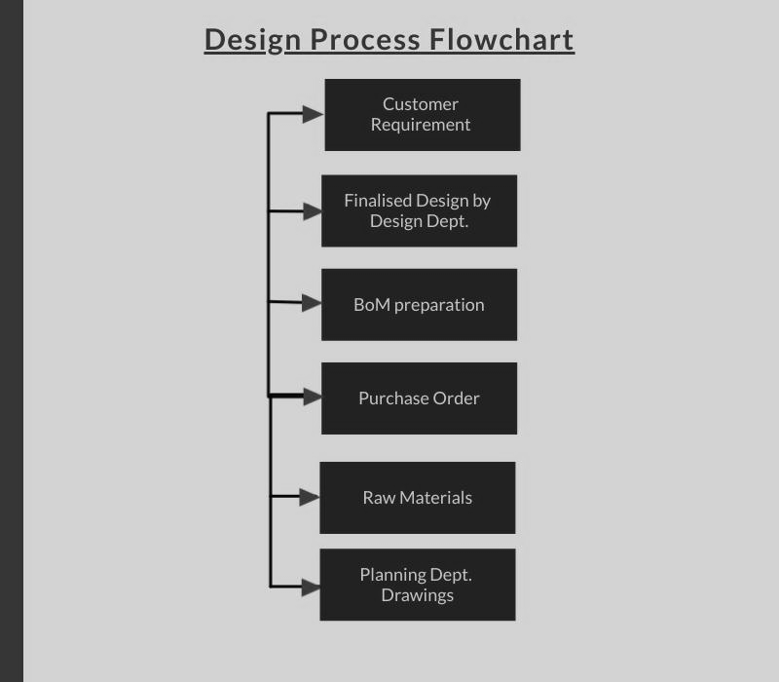

**Customer Requirement:**

The customer produces the requirement and the necessary designs and drawings of the die for manufacture which is checked by the design dept. for any improvements or changes that need to be done in order to produce a quality product with almost nil defects. If there are any changes in the design as compared to the customer requirement, the same is intimated to the customer for approval and is forwarded to design dept. for finalization of designs and drawings.

**Finalized Design**:

Once the design is approved by the customer, the design dept. finalizes the designs for manufacturing and further production of the die. For, UNIRAC die, the finalized designs are as follows:

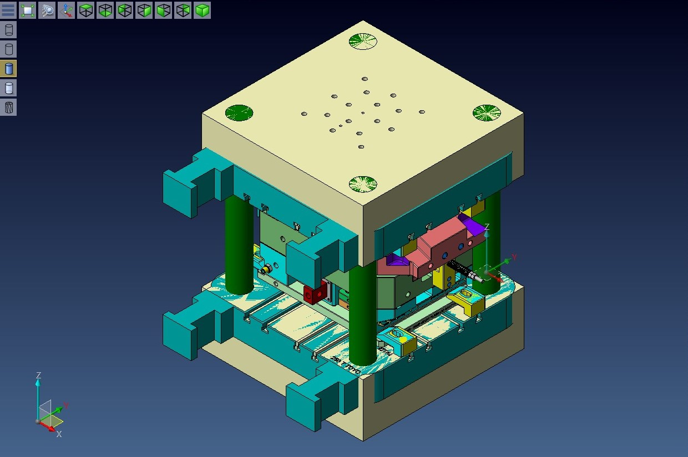

CAVITY HOUSING:

Cavity housing houses the cavity insert which is clamped in the housing with the help of screws.

CORE HOUSING:

The core housing houses the core insert which is clamped with the help of Screws.

RUNNERS:

Runners are the passages through which molten metal passes into the mould cavity.

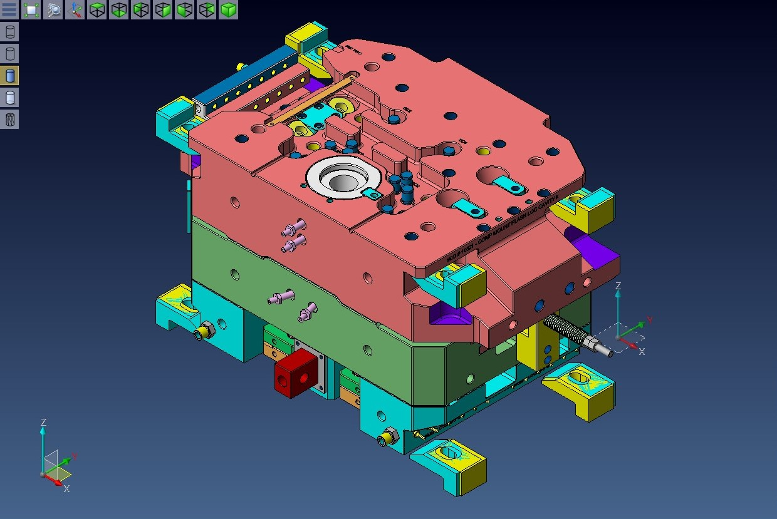

EJECTOR PINS:

The die opens after the solidification of the molten alloy, the solidified casting has to be ejected out and this is done with the help of ejector pins.

EJECTOR BACK PLATE:

It supports the ejector retainer plate for the purpose of retaining the ejector and the housing elements within the ejector retainer plate.

SPREADER AND SPRUE BUSH:

During the casting process the hot molten metal from the furnace is transferred to the shot cylinder. This shot is advanced further to the sprue bush by the plunger. The function of the spreader is to allow the molten metal or help it spread all over the gap between the core and cavity.

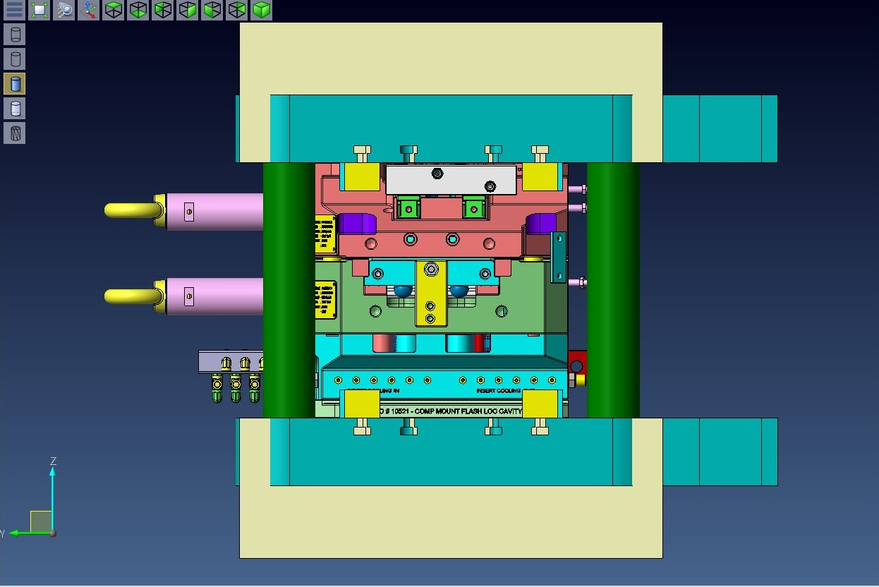

BACK PLATE:

Back plate holds the movable portion of the die assembly and is clamped to the moving plate of the die casting machine.

GUIDE PILLARS AND GUIDE BUSHES:

To form a wall thickness of the casting, it is necessary to ensure that the core and cavity are kept in alignment after every cycle. This work is done by guide pillars and bushes.

OVER FLOWS:

These are the passages through which excess material tries to escape after filling the mould cavity gap.

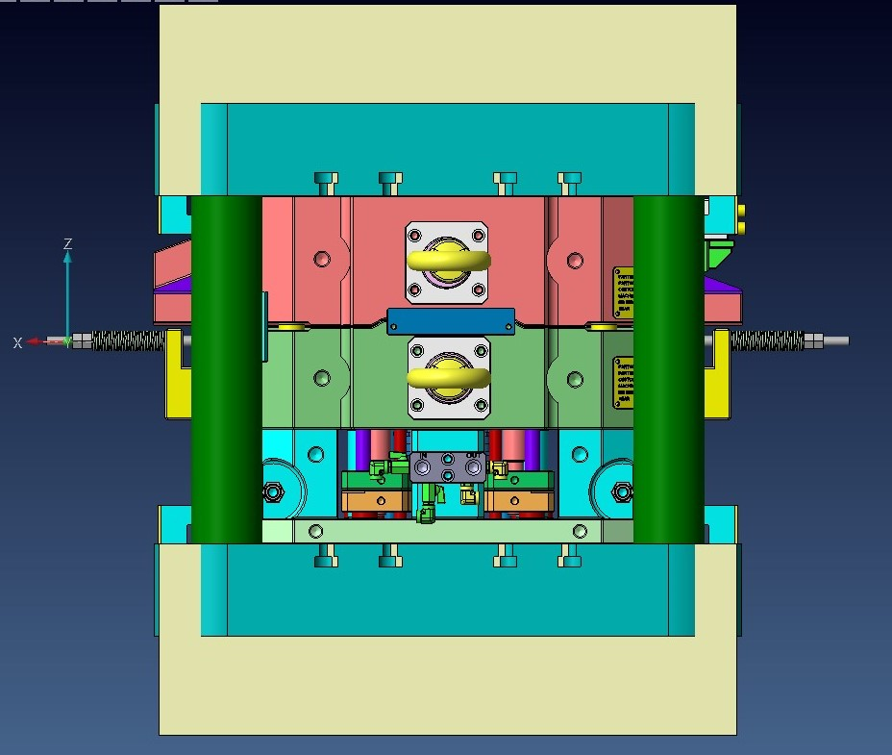

CORE PINS:

Core pins are placed in a mould cavity to shape deep and narrow holes in the part.

EJECTOR GUIDE PILLAR AND EJECTOR GUIDE BUSH:

The ejector assembly needs guiding to move forward such that the casting is ejected out in line. Therefore, the guiding of the ejector assembly is done with the help of ejector guide pillars and bushes. They are placed in the ejector retainer plate and the ejector bush is press lifted into the core housing from the bottom.

AIR VENT:

The air present inside the insert is moved out through the air vents.

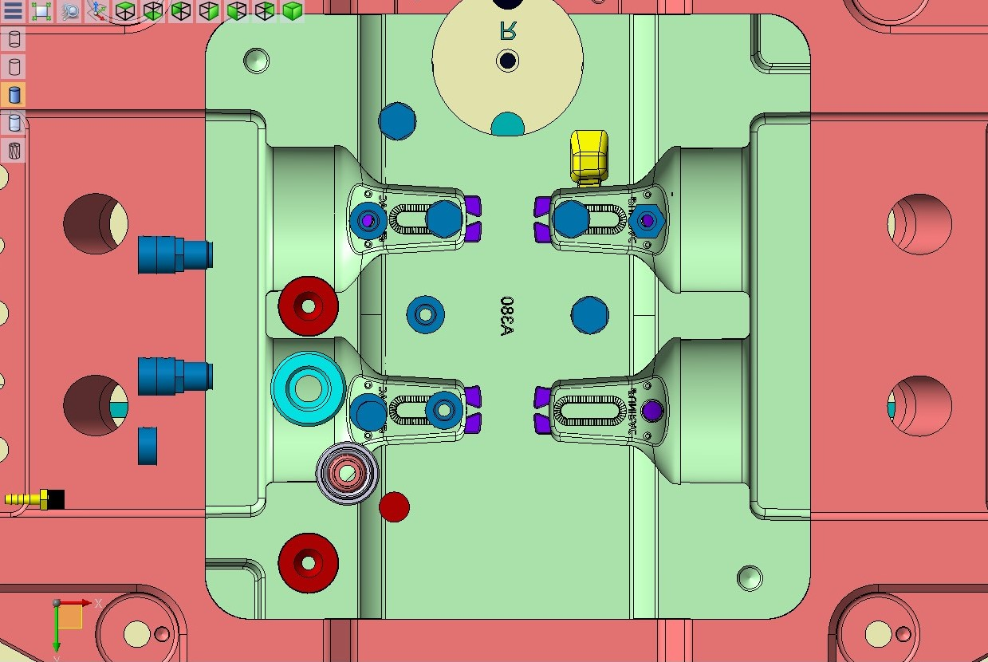

CAVITY INSERT:

A separate die component inserted into the die block to form an external feature of the cavity. Sometimes, the entire cavity block is considered as cavity insert.

CORE:

A part of the die casting that forms an internal feature of the casting and forms a separate from the cavity block.

PLUNGER BUSH:

Plunger bush is placed in a fixed die insert, along with the rod it helps in injecting the molten material into the die.

**BoM (Bill of Material):**

A bill of materials or product structure (sometimes bill of material, BOM or associated list) is a list of the raw materials, sub-assemblies, intermediate assemblies, sub components, parts and the quantities of each needed to manufacture an end product.

A BOM may be used for communication between manufacturing partners, or confined to a single manufacturing plant. A bill of materials is often tied to a production order

BOM is divided into three lists, MB Vap Items BoM, M&D Vap Items BoM, BoM-MD Cooling & L.S & Fasteners & STD Items and Screws BoM:

The first list consists of the major parts of the die which are mostly outsourced jobs in the Bill of Materials.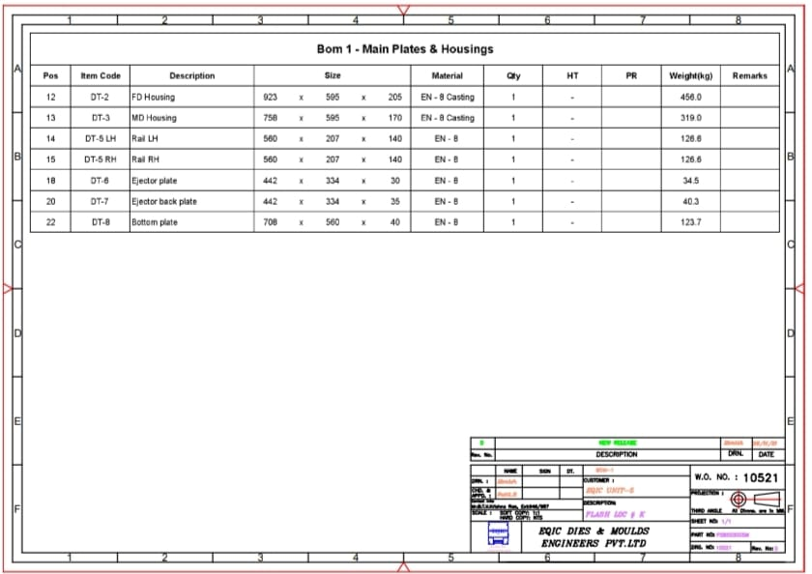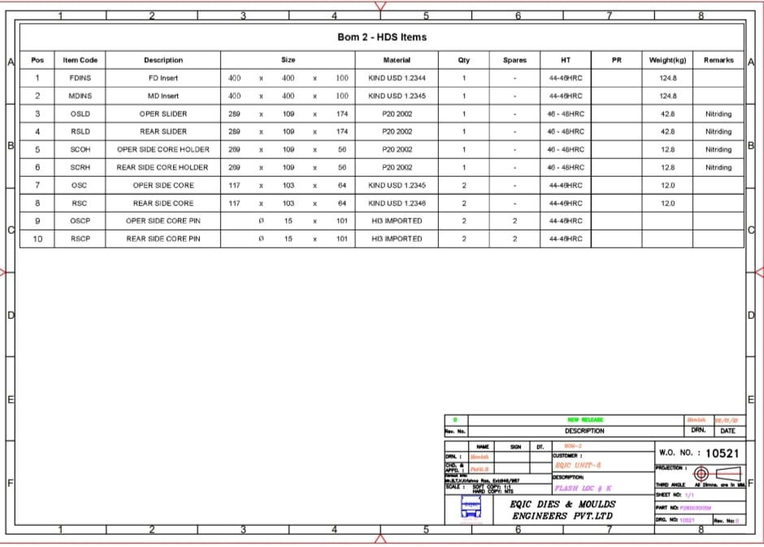These are the materials used which don't appear after the die is assembled; these help in completion of the core and the cavity insert.

These also play a very important role in the ejection of the component; the core pins help in making holes in the component if there are any in the component and the ejector pins help in the ejection of the component.

Plunger bush is the opening through which the molten material is poured into the cavity and Spreader helps in the equal distribution of the molten material into the cavity.

The remaining parts like local insert guides, wedges, side cores, and slider help in the completion of the core and the cavity. Sliders are also fitted with hydraulic pushers which are automated and reduce the manpower and increase the precision in manufacturing of the die.

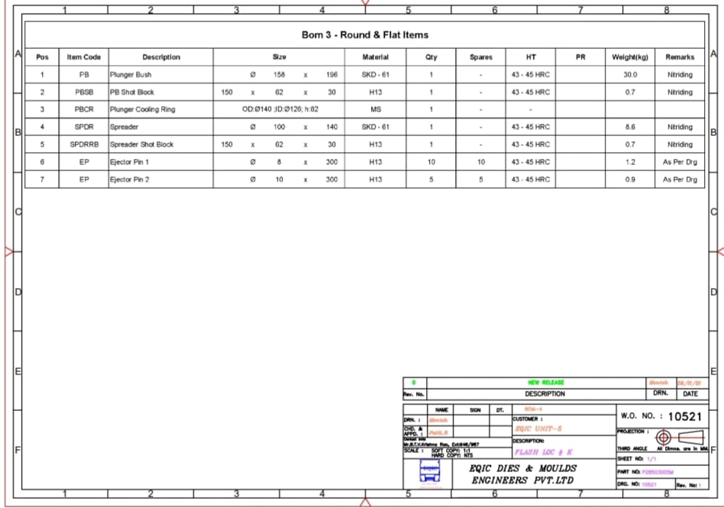

These are the basic parts for assembling the die; these are mostly the outsourced jobs. Die manufacturing comes to a halt in the absence of these parts.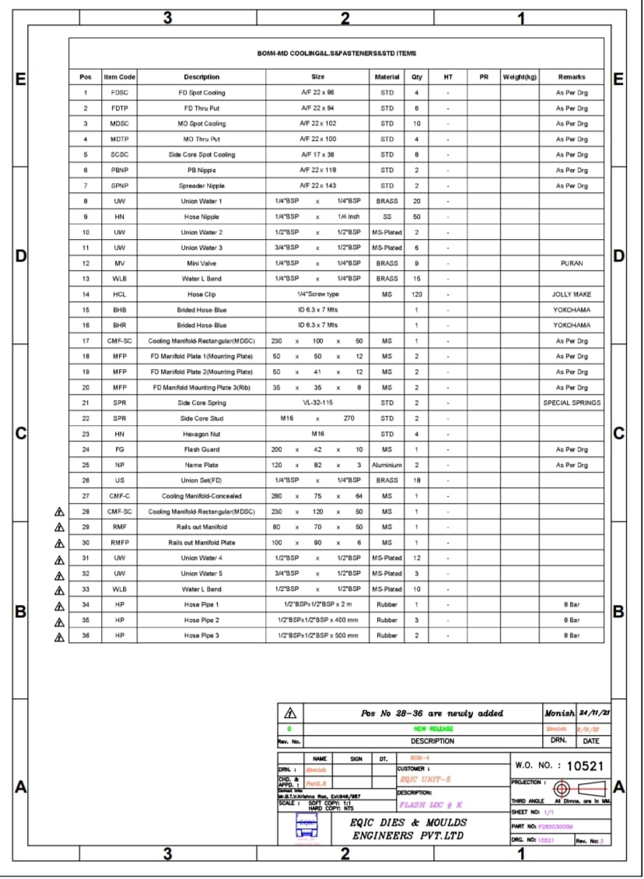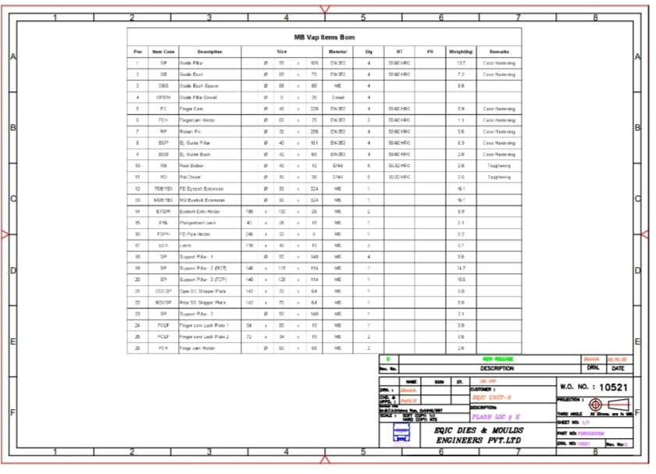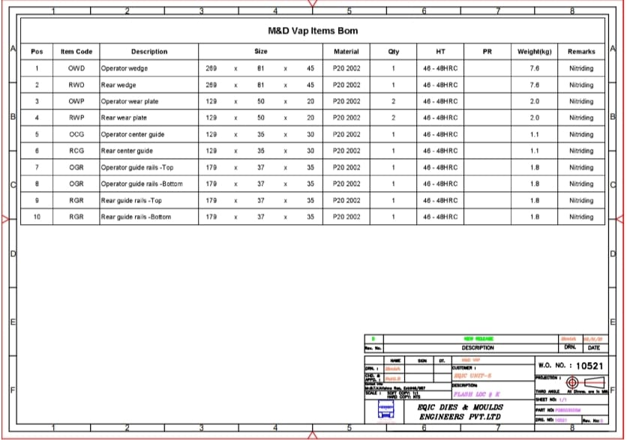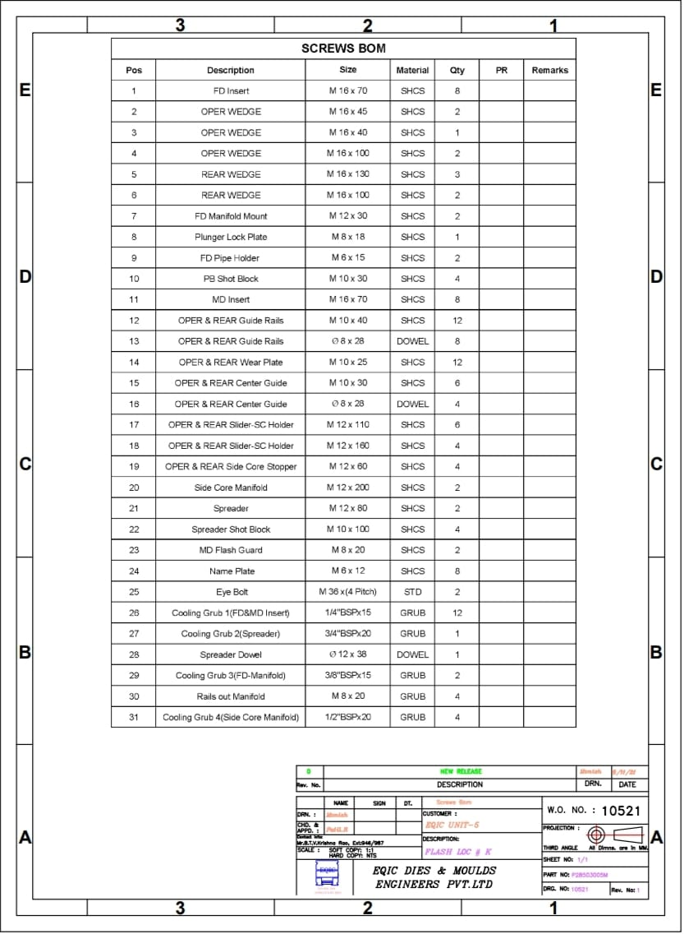

**Purchase order:**

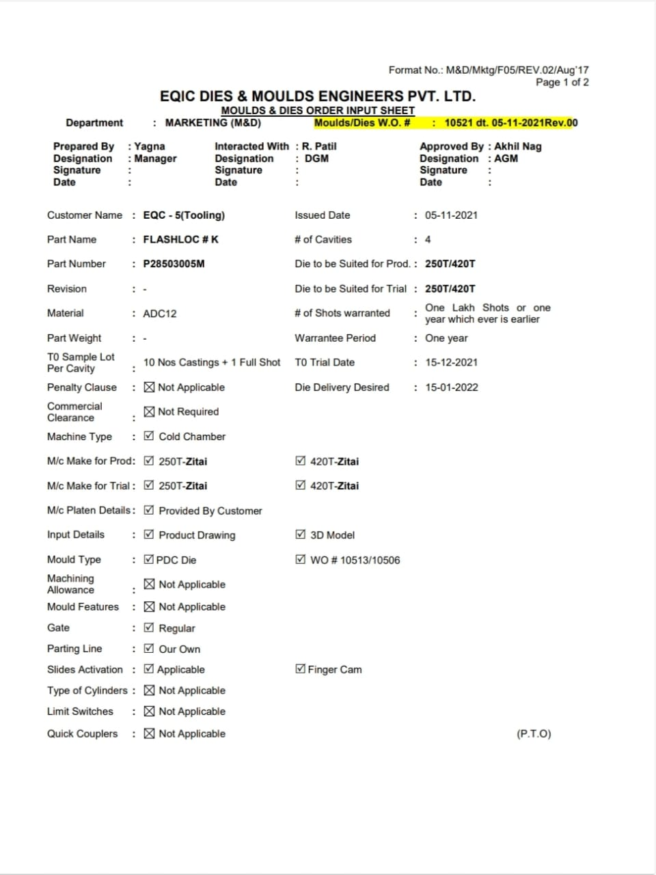

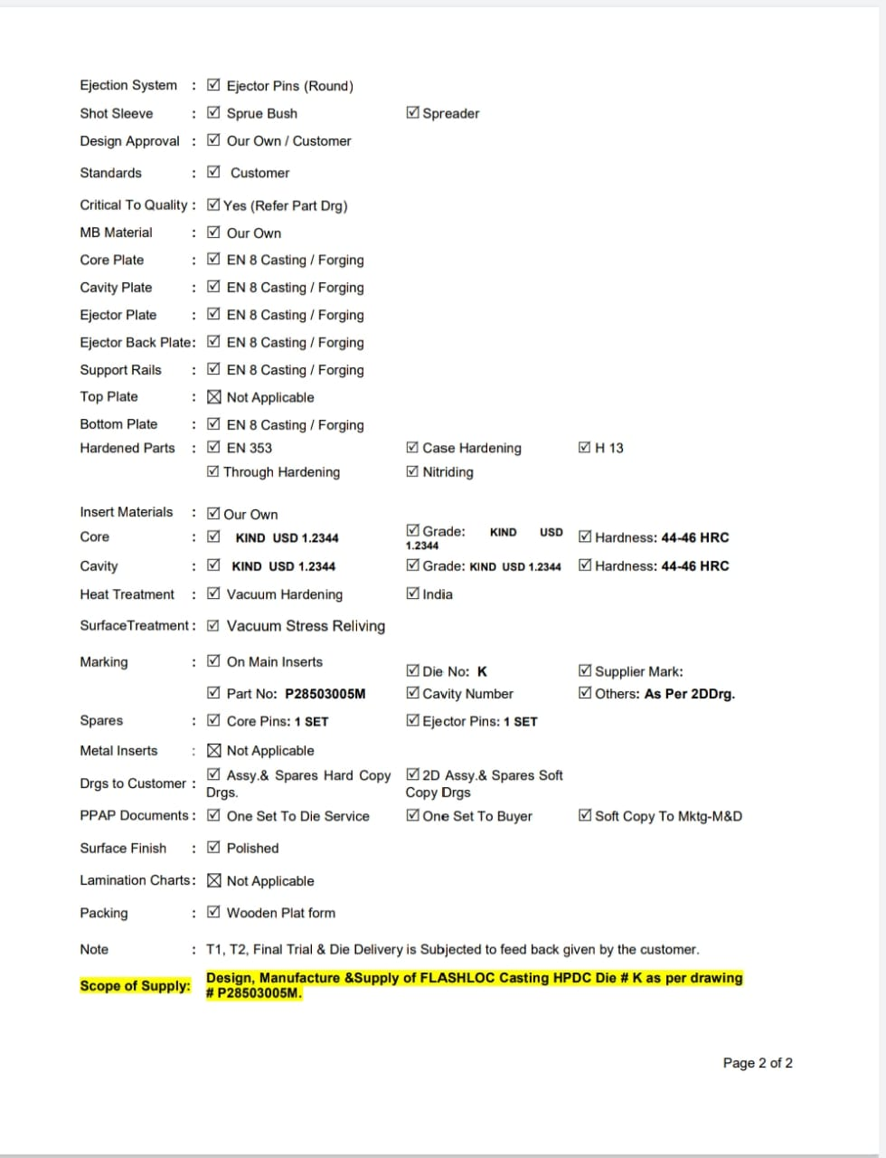

**Die Manufacturing Process**

**Block up activity:**

If the raw material is perfect, it then goes to the next step that is block up-milling. In up milling, chip thickness starts at zero and increases toward the end of the cut. Cutting forces tend to push the cutter and work piece away from each other. In up-milling, the feed direction of cutting tool is opposite to its rotation.

Raw material procured has some stock. It may also have some scaling on the surface. To remove this, it is sent to milling where some of the excess material is removed but it still has stock. Different milling machines are used based upon the size and load of the material.

**DRILLING:**

Drilling is the process of cutting holes in a solid material using a rotating cutting tool. The indentation is a starting point for the drilling of the hole. Drilling is a cutting process in which a drill bit is used to cut or enlarge a hole in a solid material.

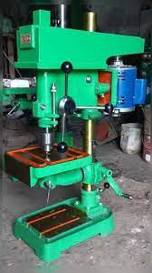

**Boring:**

Boring is the process of enlarging a hole that has already been drilled, by means of a single poi cutting tool.

There are various types of boring. The boring bar may be supported on both ends (which only works if the existing hole is a through hole), or it may be supported at one end (which works for both through holes and blind holes). Line boring (line boring. line-boring) implies the former. Back boring (back boring, back-boring) is the process of reaching through an existing hole and then boring on the "back" side of the work piece (relative to the machine headstock).

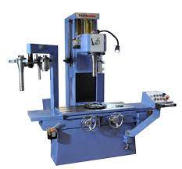

**Tapping:**

Taps and dies are cutting tools used to create screw threads, which is called threading. A tap is used to cut the female portion of the mating pair (e.g., a nut). A die is used to cut the male portion of the mating pair (e.g., a bolt). The process of cutting threads using a tap is called tapping, whereas the process using a die is called threading. Both tools can be used to clean up a thread, which is called chasing.

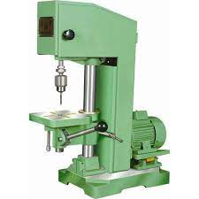

**CNC Machining:**

It is a computerized manufacturing process in which pre-programmed software and code controls the movement of production equipment. CNC machining controls a range of complex machinery, such as grinders, lathes, and turning mills, all of which are used to cut, shape, and create different parts and prototypes.

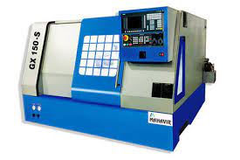

ADVANTAGES OF CNC MACHINES:

1. CNC machines can be used continuously 24 hours a day, 365 days a year and only need to be switched off for occasional maintenance.

2. CNC machines are programmed with a design which can then be manufactured hundreds or even thousands of times. Each manufactured product will be exactly the same.

3. Less skilled/trained people can operate CNCS unlike manual lathes/milling machine. CNC machines can be updated by improving the software used to drive the machines

5. Training in the use of CNCS is available through the use of virtual software. This is software that allows the operator to practice using the CNC machine on the screen of a computer. The software is similar to a computer game.

6. CNC machines can be programmed by advanced design software such as Pro DESKTOP". Enabling the manufacture of products that cannot be made by manual machines, even those used by skilled designers / engineers.

DISADVANTAGES:

1. CNC machines are more expensive than manually operated machines, although costs are slowly coming down.

2. The CNC machine operator only needs basic training and skills, enough to supervise several machines. In years gone by, engineers needed years of training to operate centre lathes, milling machines and other manually operated machines. This means many of the old skills have been lost.

**Heat Treatment Process:**

Heat treating is a group of industrial and metalworking processes used to alter the physical, and sometimes chemical, properties of a material. The most common application is metallurgical. Heat treatments are also used in the manufacture of many other materials, such as glass. Heat treatment involves the use of heating or chilling, normally to extreme temperatures, to achieve a desired result such as hardening or softening of a material. Heat treatment techniques include annealing, case hardening, precipitation strengthening, tempering and quenching.

It is noteworthy that while the term heat treatment applies only to processes where the heating and cooling are done for the specific purpose of altering properties intentionally, heating and cooling often occur incidentally during other manufacturing processes such as hot forming or welding.

For The material first the required hardness is obtained. This is done by first performing hardening and then tempering. Mainly vacuum heat treatment is done. VHT takes about 2 hours.

Then the material is cooled; this may be done by oil cooling or air cooling.

Quenching is a process of cooling a metal at a rapid rate. This is most often done to produce a marten site transformation. In ferrous alloys, this will often produce a harder metal, while nonferrous alloys will usually become softer than normal.

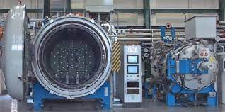

After the material comes from heat treatment it is observed that it is slightly bent. On a grinding machine its parallelity is checked and machined. But the complete stock is not removed.

**Electrical discharge machining:**

Electric discharge machining (EDM), sometimes colloquially also referred to as spark machining, spark eroding, burning, die sinking, wire burning or wire erosion, is a manufacturing process whereby a desired shape is obtained using electrical discharges (sparks).

Material is removed from the work piece by a series of rapidly recurring current discharges between two electrodes, separated by a dielectric liquid and subject to an electric voltage. One of the electrodes is called the tool-electrode, or simply the 'tool' or 'electrode', while the other is called the work piece-electrode, or 'work piece'.

Sinker EDM, also called cavity type EDM or volume EDM consists of an electrode and work piece submerged in an insulating liquid such as, more typically, oil or, less frequently, other dielectric fluids. The electrode and work piece are connected to a suitable power supply. The power supply generates an electrical potential between the two parts. As the electrode approaches the work piece, dielectric breakdown occurs in the fluid, forming a plasma channel, and a small spark jump.

These sparks usually strike one at a time because it is very unlikely that different locations in the inter-electrode space have the identical local electrical characteristics which would enable a spark to occur simultaneously in all such locations. These sparks happen in huge numbers at seemingly random locations between the electrode and the work piece. As the base metal is eroded, and the spark gap subsequently increases, the electrode is lowered automatically by the machine so that the process can continue uninterrupted.

Several hundred thousand sparks occur per second, with the actual duty cycle carefully controlled by the setup parameters. These controlling cycles are sometimes known as "on time" and "off time", which are more formally defined in the literature.

The on-time setting determines the length or duration of the spark. Hence, a longer on time produces a deeper cavity for that spark and all subsequent sparks for that cycle, creating a rougher finish on the work piece. The reverse is true for a shorter time. Off time is the period of time that one spark is replaced by another. A longer off time, for example, allows the flushing of dielectric fluid through a nozzle to clean out the eroded debris, thereby avoiding a short circuit.

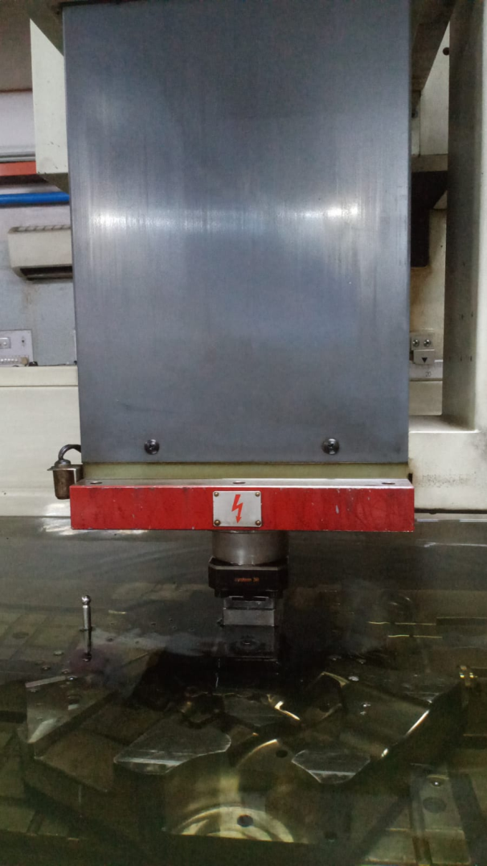

**Wire Cut EDM:**

There are two main types of EDM: conventional, or sinker, and wire, or wire cut. Conventional EDM, as described above, uses a tool to disperse the electric current. This tool, the cathode, runs along the metal piece, the anode, and the electrical current reacts to melt or vaporize the metal. As a result of the dielectric fluid, usually a hydrocarbon oil into which both the cathode and the work piece are immersed, the minute chips produced by the process wash away from the piece. Wire cut EDM (or WCEDM) discharges the electrified current by means of a taut thin wire, which acts as the cathode and is guided alongside the desired cutting path, or kerf. The dielectric fluid in this case—usually deionised water—is flushed through the cut as it proceeds, again serving to carry off particles and control the sparks.

Because of its versatility, manufacturers use EDM wire cutting machine operation for an extensive range of applications. Because the process can cut very small pieces, it is often an ideal choice for the production of small, highly detailed items that would normally be too delicate for other machining options. Additionally, the process is cost-effective for low quantity projects and can prove to be beneficial in prototype manufacturing, even if the actual project is carried out by different means.

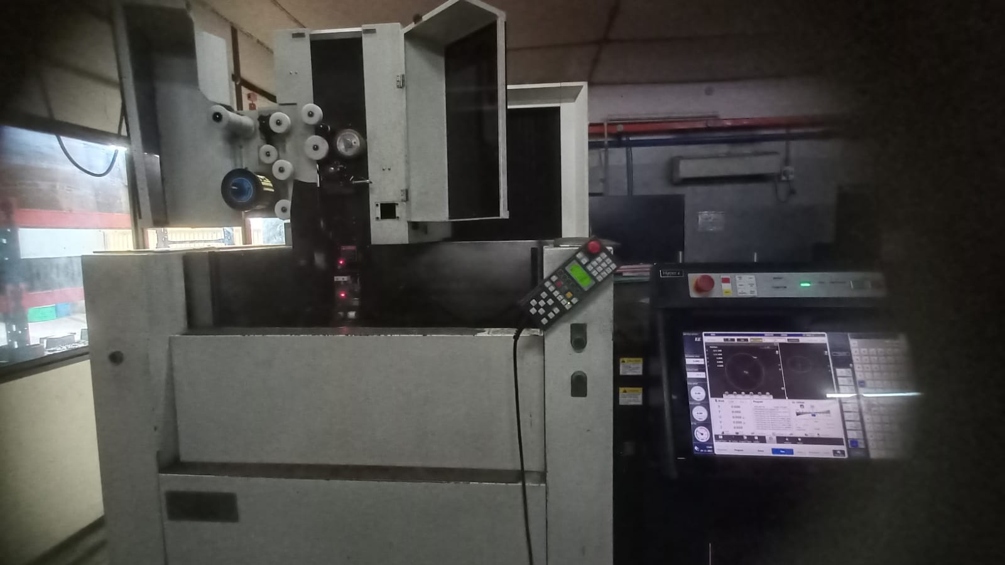

**Assembly of the Die**

When the die and other components arrive at the assembly unit, first inspection of the die and those components are done. To check for any errors and to verify whether the components are machined to the dimensions and tolerances specified in the drawing sheets. The inspection is done using tools like venire callipers and screw gauge.

If there are some errors or differences in the dimensions of the die while inspecting, it is noted and sent back to the manufacturing unit to make the required corrections.

After the required corrections are done, the die undergoes one final inspection to check all the required inspections and if everything is up to the standards the Assembly process is started.

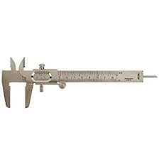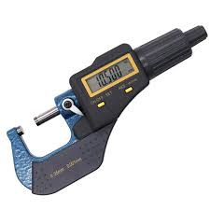

Assembly Process:

The different parts assembled are:

1. Moving Die
2. Mould Bases
3. Fixed Die
4. Ejector Plate
5. Back Plate
6. Core pins
7. Side cores
8. Spreader
9. Ejector Pins
10. Cooling System
11. Support rails
12. Sensors
13. Screws

Moving and Fixed Die:

Moving die has the core profile and the fixed die has the cavity profile. Both the fixed die and the moving die have separate mould bases and in the first step of the assembly process, the moving and fixed die are attached to their respective mould bases.

These mould bases are usually made of mild steel or iron. They are manufactured using the process of sand casting. Some mould bases also undergo heat treatment to achieve the required hardness and structural stability.

It is also machined and surface finished accommodating the die insert properly.

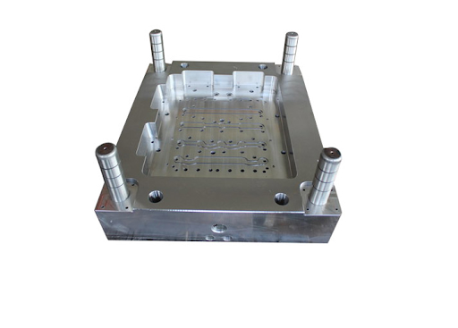

**Mould Base**

Ejector Plate and Back Plate:

Ejector Plate and the Back plate are used to eject the component out of the die after the die casting process is completed. Ejector plate is placed on the moving side of the die and this plate pushes the component. Ejector plates have a controlled movement and are guided using the guide rails. Ejector plates are usually made using the process of forging. It is usually made of EN8 steel.

Back plate is assembled behind the ejector plate; it constrains the motion of the ejector plate during the return stroke. Similar to the Ejector plate, the back plate is also forged and is made up of EN8 steel.

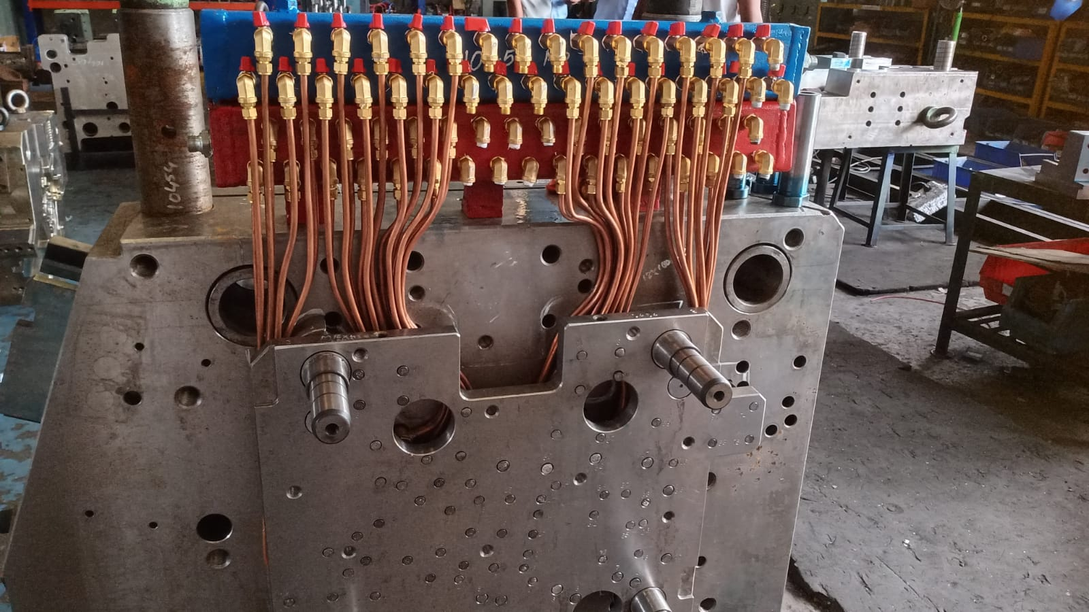

Core Pins:

Core pins are fixed elements that are used to create voids, providing the desired shape of the casted component. The core pins are attached to the die at the required positions. These core pins are usually made up of mild steel and are machined using a cylindrical lathe. After the part is machined it also undergoes surface finishing like surface grinding. Then the core pins are fastened to the dies.

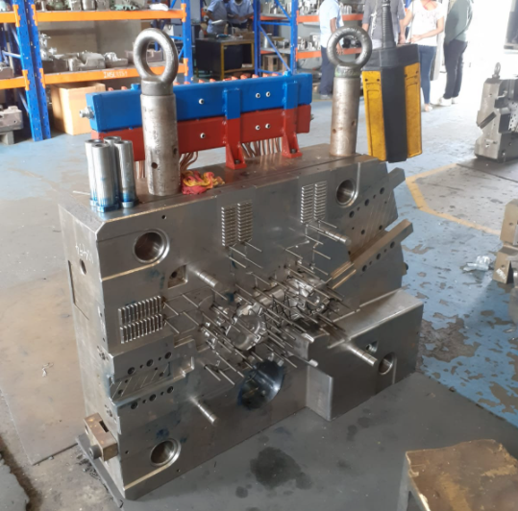

**Core pins attached to the die**

Side cores:

According to the shape and features of the component that has to be manufactured, side cores are attached to the mould base. The position and design of the side core is already designed by the design team. These side cores are manufactured in the same way as the die. They are manufactured using CNC machines up to the required dimensions. After coming to the assembly unit, they are also inspected. These side cores are attached to the mould base. The side cores are movable. The side cores are moved while ejecting the component.

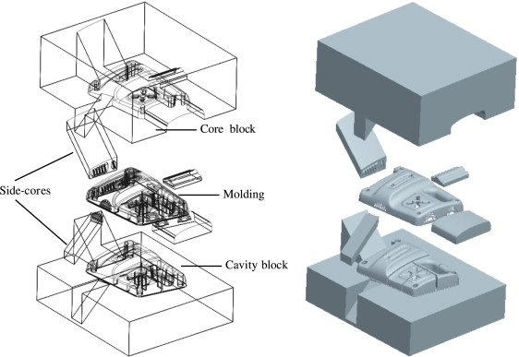

Spreader:

The moving part of the mould base also houses the spreader through which the molten metal entering is sent to insert via runners. Unit

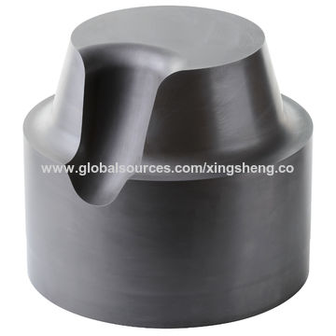

Ejector Pins:

These pins are used to eject the component out of the die. These pins are moved by the ejector plate. The ejector plate pushes these pins which push the component out of the die.

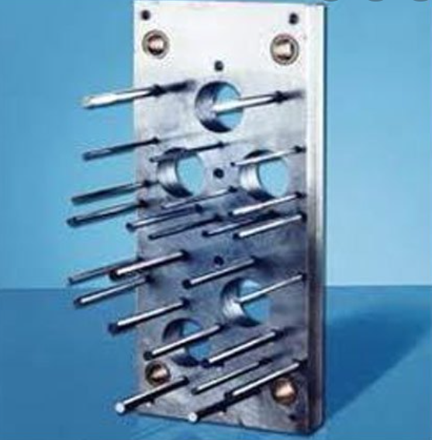

**Ejector pins attached to the ejector plate**

Blue Matching:

In this step of the assembly process, it is inspected if the moving and the fixed half are closing properly and alignment issues are inspected.

The fixed half is painted blue. The total area is painted blue without leaving any space.

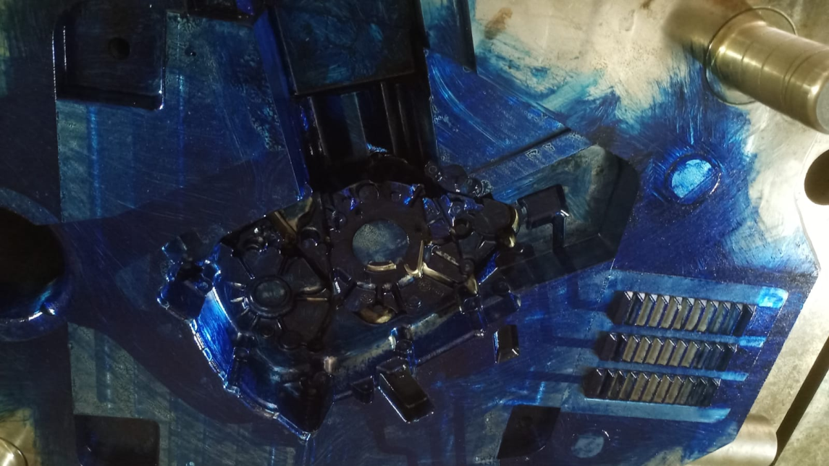

Then the moving half and the fixed half are lifted and placed on to the hydraulic press to inspect the alignment. In this machine the moving half is kept static and the fixed half is pressed against it using the hydraulic press.

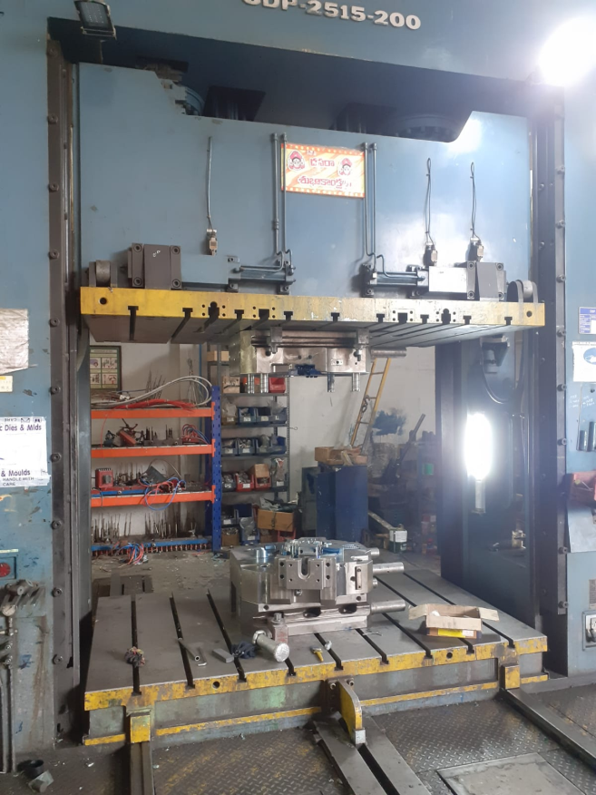

This step also ensures that the molten aluminium won’t seep out of the die while the production process is done.

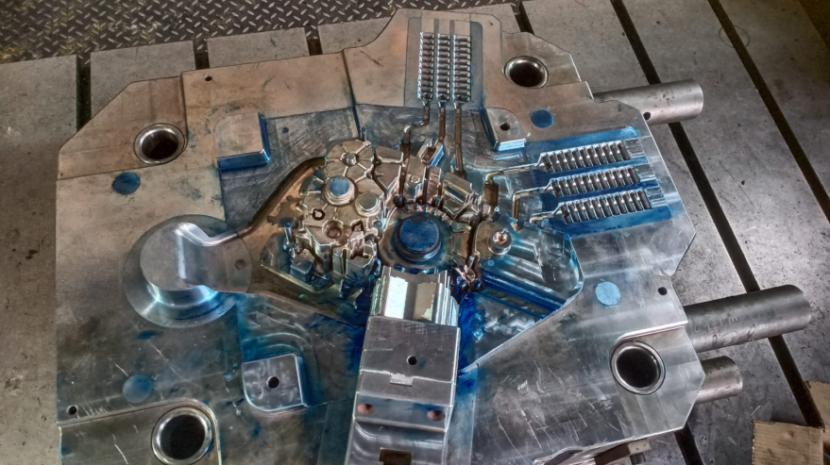

Cooling System:

The cooling system is attached to provide cooling to the die and increase its performance. When the die doesn’t get enough time to cool then the performance of the die is hindered.

The cooling manifold contains all the valves of the cooling system. The pipes of the cooling system are also attached to this cooling manifold. The cooling manifold is the heart of the cooling system which controls the total movement of the coolant.

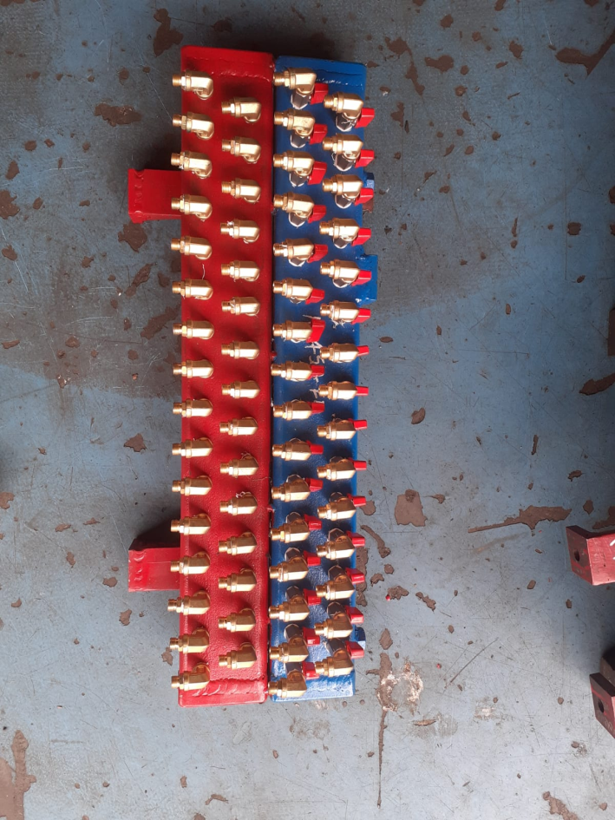

After the pipes are attached to the cooling manifold the cooling system is attached to the mould base.

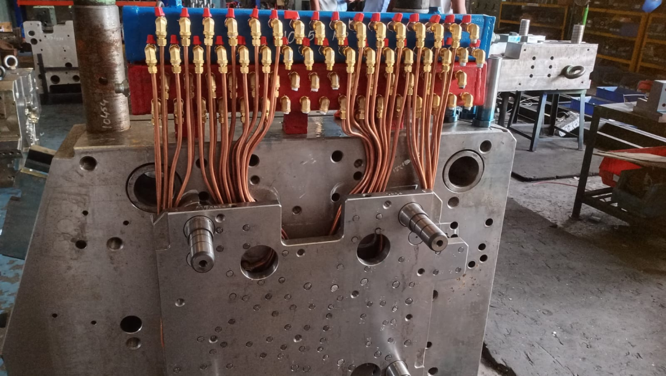

Cylinders:

First the mould bases are attached to the die housings which give extra structural stability and house the cylinders that control the movement of the side cores.

These cylinders are hydraulic cylinders and the cylinders are mostly custom made for the die. The force exerted by the cylinder depends on the volume of the cylinder and the liquid present in the cylinder.

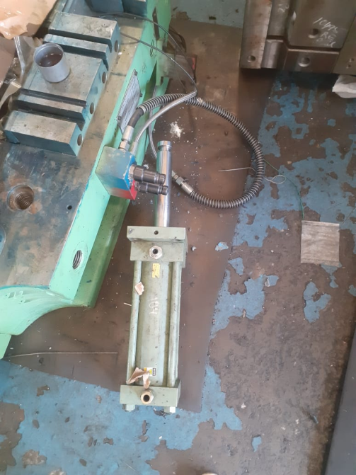

The assembly of the die is completed at this stage the die then goes for trail-0.

Where the die is tested by performing die casting. One or two parts are produced and they are inspected to see if the die can withstand 1 Lakh shots. Also, the components are thoroughly inspected for all the dimensions and surface aspects.

After the trial-0, the component is taken for inspection where it is 3d scanned.

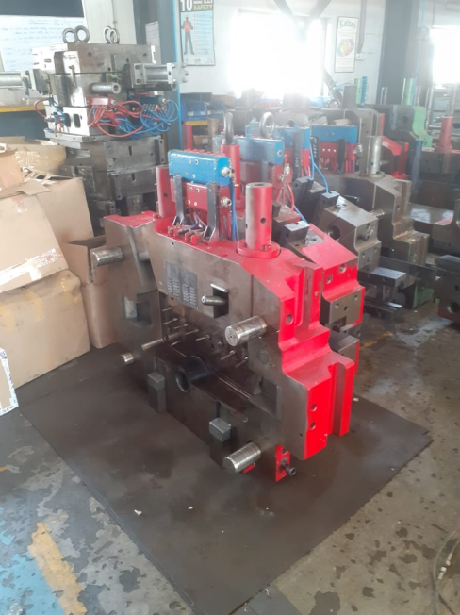

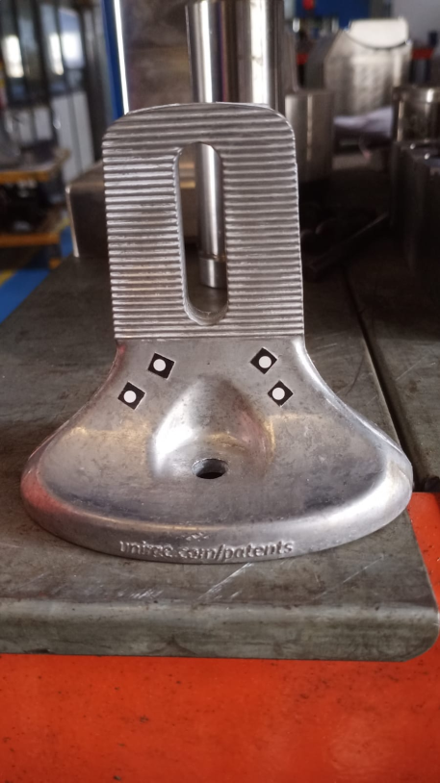

Here stickers are attached to the component and are scanned according to the shape of the component a 3d model is generated, this 3d model is compared with the original 3d design of the component and is checked for any differences. If both the models match the die is good to go for production. If they don’t match, the client is notified and required changes are made to the die.

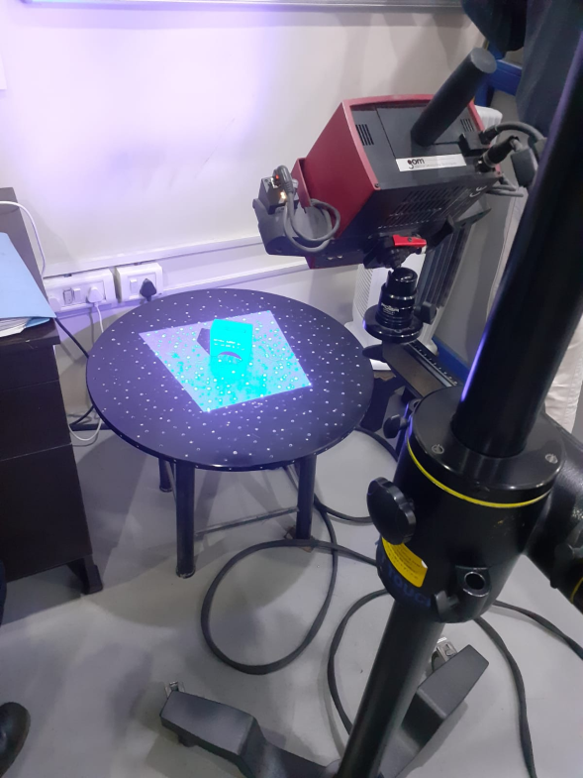

**Production**

Tyche Diecast Pvt. Ltd. is a reputable company, part of the EQIC Group Company, which was established in 1996 for manufacture of Aluminium Pressure Die Castings-fully machined. TYCHE emerged as a leading Aluminium pressure die cast components supplier for Two Wheelers, passenger cars, commercial vehicles, Defence through tier-1/tier-2 vendors, Refrigeration/Air conditioning Compressor manufacturers.

TYCHE Manufacturing facilities are certified to **IATF 16949-2016**, **ISO 9001-2015** and **ISO 14001-2015** quality management systems. The Stringent quality systems had won the 100 PPM certification from the premier customer **M/S LUCAS TVS Ltd**. and SQ Mark Certification from **Hyundai Motor, India**

TYCHE is professionally managed by experienced technocrat entrepreneurs and engineers. Today TYCHE has capabilities for development of new products, with the support of world class tool room and in-house machining facilities. It can develop die-casting dies and supply fully machined parts at shortest delivery time.

**STEPS INVOVLED IN PRODUCTION OF MATERIAL:**

* FIFO METHOD
* CENTRAL MELTING FURNACE
* POROSITY TESTING AND DEGASSING
* SPECTRO ANALYSIS
* MOLTEN METAL TRASFERRING
* AUTO LADLE
* HIGH PRESSURE DIE CASTING
* FETTLING
* MACHINING
* INSPECTION
* DISPATCH

Generally desired products are made using Aluminum. Aluminium, silver-white light metal with ductility. Commodities are often made into rods, flakes, foils, powders, ribbons and filaments. Aluminium relative density is 2.70.

Melting point 660 C. Boiling point 2327C，Aluminum is the most abundant metal element in the crust which ranking third only after oxygen and silicon. With the development of aviation, construction and automobile industries, material properties are required to have the unique properties of aluminium or its alloys.

Aluminium and its alloys are one of the most widely used and economical materials nowadays. The smelting of metal aluminium is an important procedure in the production and processing of aluminium products. In fact, the so-called smelting is to put a certain proportion of the metal burden in the furnace, through different heating methods to melt the scrap aluminium, and then cast into the corresponding products. There are mainly three types of aluminium furnaces adopted to melt the aluminium.

**FIFO METHOD**

FIFO stands for “First in First Out”. It’s an inventory control method in which the first items to come into factory are the first items to leave. The raw materials of aluminium that are received first are the materials that are held longest and therefore closest to expiry. In order to avoid worthless inventory, the staff move these first for melting it into molten aluminium state.

**CENTRAL MELTING FURNACE**

The melting furnace is employed to overheat solid materials unit they become liquefied. The central melting furnace has 650kg/ton.

The aluminium metal is converted into molten aluminium by heating it. Typically, thermal processing equipment is utilized to change the internal characteristics or the surface of materials by elevating the temperatures carefully. The aluminium has melting point of 660.32 °C (1220.58 °F). The aluminium will almost melt immediately once it reaches this temperature. The furnace provides over hot temperature which achieve this temperature and cause decomposition of its physical structure which results in liquefaction.

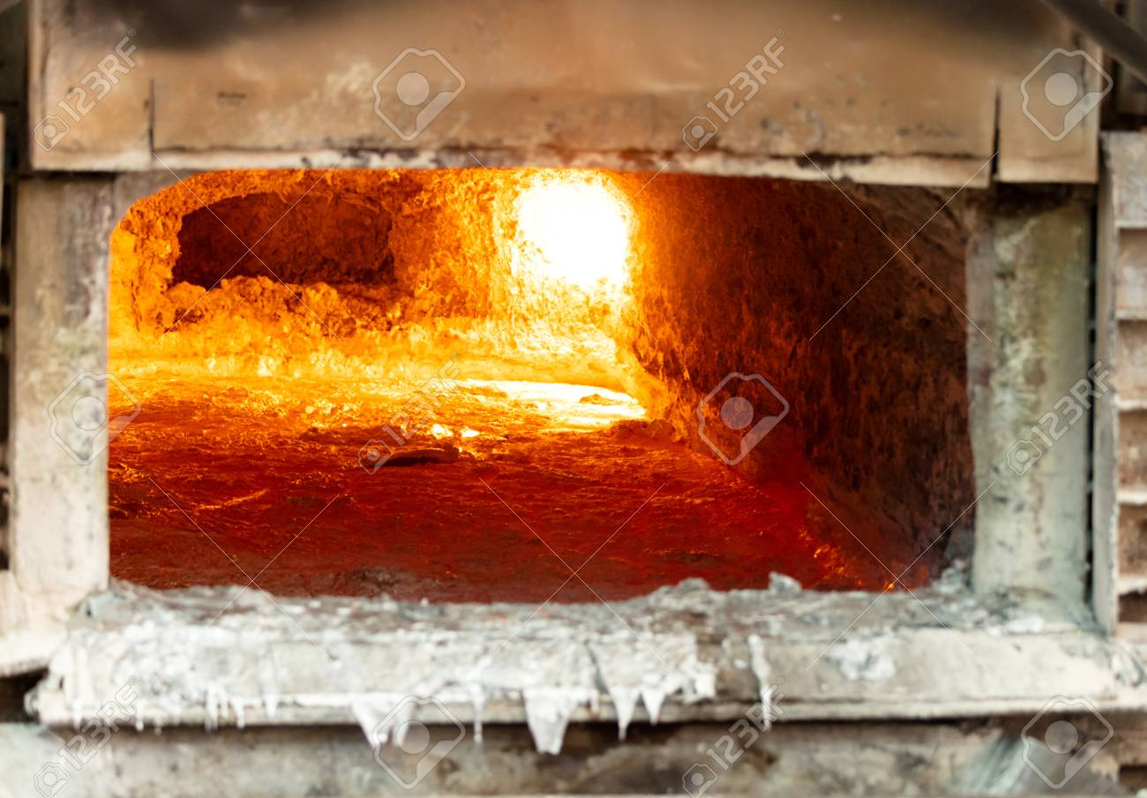

Here we use 60% of new raw material of Aluminum and 40% of recycle Aluminum. The furnace melts this material and converts it into molten aluminum state. This molten is taken out and performs required tests.

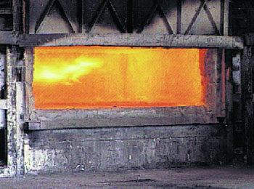

**POROSITY TESTING**

During the melting process of cast aluminium alloy, the liquid aluminium will react with the hydrogen produced by the water vapour and dissolve into the liquid aluminium. If the content of hydrogen in the liquid aluminium is too high, it is easy to form Blowhole in the aluminium castings, and the mechanical properties of the castings will be reduced. More seriously, the castings will be scrapped. So, Hydrogen is a harmful gas in molten aluminium. Detection of hydrogen content in molten aluminium is an important procedure to ensure the quality of castings. Especially, in the mass production of large capacity.

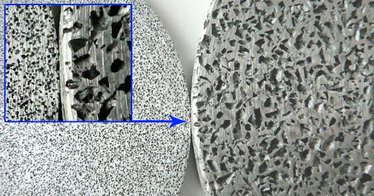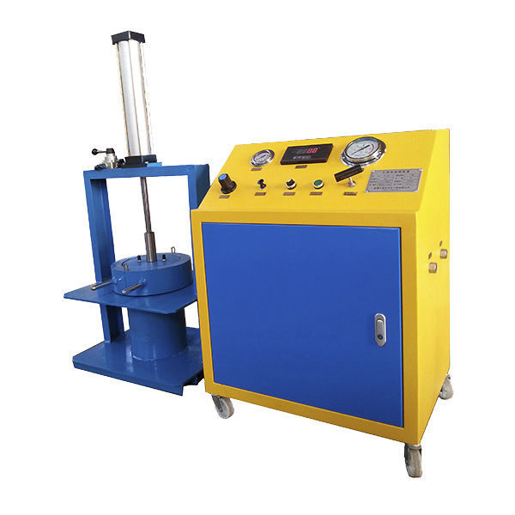

This hydrogen content of aluminium leads to porosity of metal. This porosity is detected by using machine called porosity testing machine.

The working principle of the Aluminium liquid degassing and slag removal refining machine is that the rotating graphite rotor breaks the inert gas (argon or nitrogen) into a large number of dispersed bubbles and disperses them in the liquid aluminium.

Bubbles in molten aluminium absorb hydrogen in molten aluminium and adsorb oxidized slag by the principle of partial pressure difference of gas and surface adsorption, and are brought out of the surface of molten aluminium with the rising of bubbles.

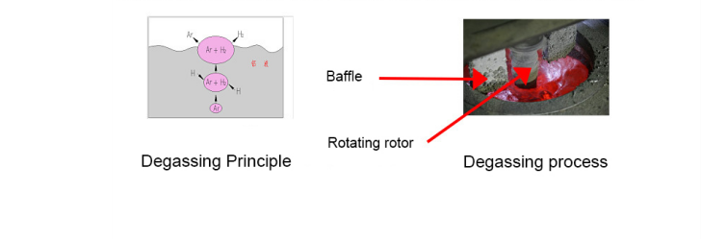

The liquid aluminium can be purified; because the bubbles are fine and dispersed; they mix with the rotating melt evenly, and then rotate in a spiral shape and float slowly. When contacting with the liquid aluminium, there will be no continuous straight upward air flow. Thus, the purification effect is significantly improved. The degassing medium is recommended to use more than 99.996% of the nitrogen or argon (considering the cost, nitrogen is recommended). The whole degassing system is installed on a movable cart, which can degasser the liquid aluminium in different positions conveniently. Because its graphite rotor can rise and fall up and down, it can provide degassing for almost all types of furnace body.

**SPECTRO ANALYSIS**

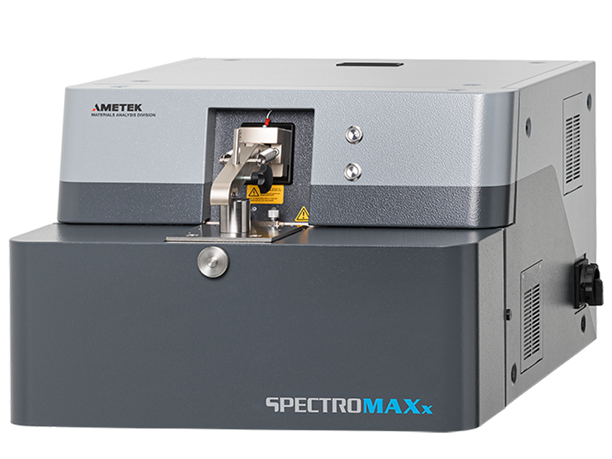

SPECTRO metal analysers are used to identify, sort, and analyse metals for incoming inspections, during production processes and before delivery. For chemical of the aluminium metal the machine used is called Spectro Maxx.

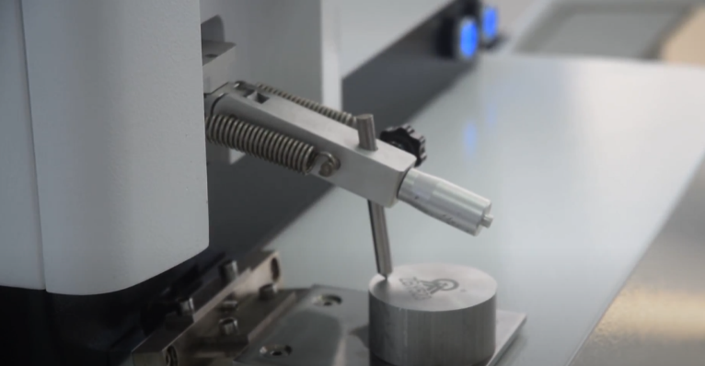

The Spectro Maxx is chemical analysis aluminium sample. The aluminium sample is placed on the electrode of Spectro Maxx machine. By a shot on the aluminium sample. We get the different compositions of metals, displayed on the computer system.

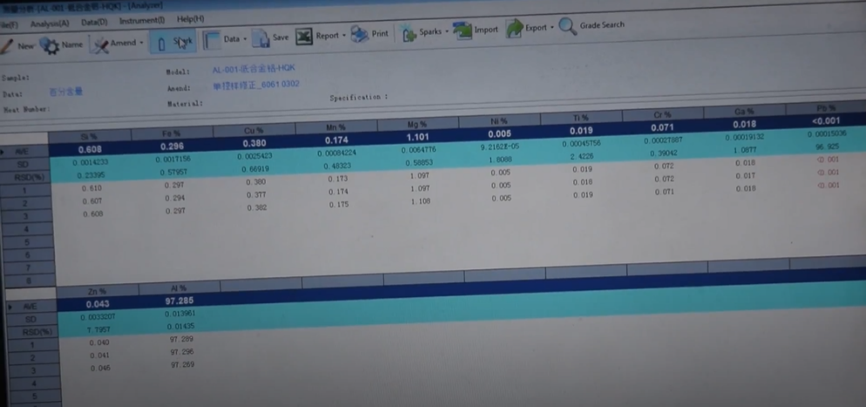

**MOLTEN METAL TRANSFERING**

The molten metal of aluminium from the furnace is transferring into the metal transfer furnace. In this furnace the temperature of the motel metal is maintained constant. The temperature of the molten metal is maintained same; it prevents the metal from solidification. The transfer ladle is used to transfer molten metal from one process to another process.  Typically, a transfer ladle will be used to transfer molten metal from a primary melting furnace to a holding furnace.

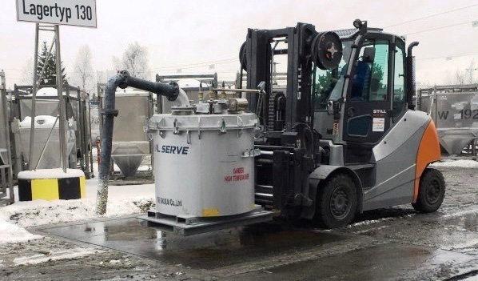

**AUTO LADLE**

This auto ladle transfer’s molten aluminium metal from a single holding furnace to a single Gravity die casting machine acting as point to point system, working on auto cycle with machine without separate commands for its working.

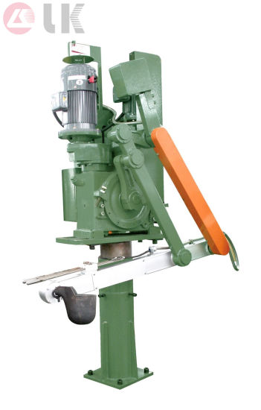

Auto ladle consists of an adjustable pedestal over which a gearbox with two motors is mounted. One motor moves the dipper from furnace to machine and back from machine to furnace, with the help of a crank and arm. The other motor rotates the dipper clockwise and anti-clockwise to pick up metal from the furnace and discharge into the machine.

Features:

* Variable angular speed of the dipper and crank in MMI
* Variable Shot weight and timer value in System Panel
* Shot weight carrying capacity can be up to 5kgs.

**HIGH PRESSURE DIE CASTING**

**Aluminium die casting** is a process used to manufacture a type of aluminium known as [die casting aluminium](https://www.aludiecasting.com/aluminium-die-casting/). Aluminium is first moulted using high-pressure techniques. The pressure is maintained usually 800bar.

Then, in the die casting **manufacturing** process, the metal is hardened in the moulds and different shapes are produced. The aluminium die casting produced as a result of this process is an alloy that has a range of characteristics, which make it ideally suited to a number of different uses.

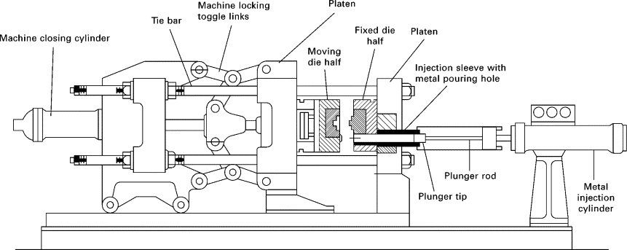

* The two halves of the die mould are first cleaned to remove any residue from the last injection. Then, each half is lubricated to facilitate ejection from the mould later on in the process. After lubrication, the two halves of the die are properly clamped together. Sufficient force is needed to keep the two dies securely clamped together. The time needed to close and the clamp will increase with the size of the machine.
* Requires the cold chamber process, the method of transfer to the chamber is manually ladling the molten metal into the shot chamber from where a hydraulic powered plunger will push the molten aluminium into the die. The injection time is the time required for the molten metal to fill all parts of the cavity. This is usually a very short time to prevent the molten aluminium from solidifying too early, before having filled the mould. For the cold chamber process machine, the injection time also includes the time it takes to manually ladle the molten aluminium into the chamber.
* The hydraulic-powered plunger that was used to inject the molten metal in the die remains in the forward position to keep pressure on the molten metal as it solidifies. Once, the aluminium completely solidifies, the shape is formed. The die can only be opened once the required cooling time has passed and the metal has solidified. Thicker walls will require longer cooling times.
* Once the cooling time has passed, the die cavity can be opened and the ejection mechanism can be employed to push the casting out. The ejection mechanism will need to employ some force in pushing the casting out as the part usually shrinks while cooling and adheres to the die. Once the casting is ejected, the die cavity is closed and ready for the next injection.
* During the cooling process, some aluminium will have solidified and attached itself to the walls of the channels of the die. These redundant elements will need to be removed. This removal is called trimming. This can be done manually in which case sawing or cutting will be the method employed, or it can be done using a trimming press. The trimmed aluminium can be disposed of or recycled.

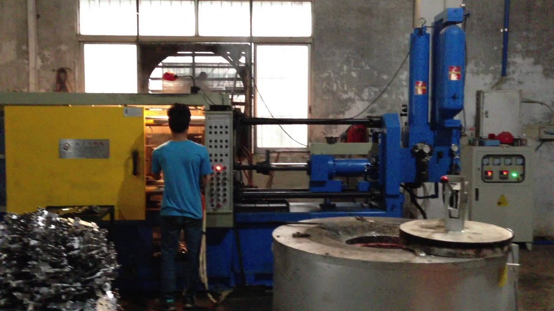

High Pressure [die casting aluminium alloy components](https://www.aludiecasting.com/aluminium-die-casting/) have the following advantages compared to the ones made by other casting methods.

* High productivity.
* Low wastage in the metal casting process.
* The very thin section can be casted easily.
* Do not require further machining.
* Good as-cast surface finish and appearance.
* Can be casted within close dimensional tolerance.
* Rejection due to casting defects is low.

FETTLING

Fettling is the process of removing excess material from castings often formed dies parting lines during the casting process when the molten metal is injected into the die.

 It involves removal of the cores, gates, risers, cleaning of the as surface and chipping of any of the unnecessary projection on the surfaces.

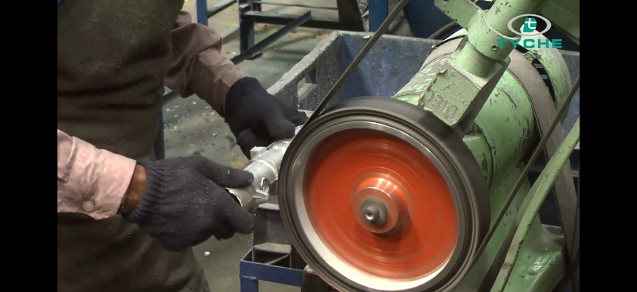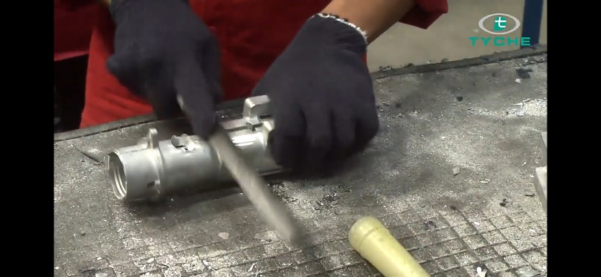

After the die casting the felting has to be done for removing the excess material and to get smooth surface.

MACHINING

Machining is used to introduce features that cannot be produced during the casting process. This is due to the very small tolerances of the design dimensions. In these instances, a 'machining allowance' is incorporated at the design stage so that the casting can eventually be machined back to the exact dimensions.

* **MACHINING CENTER WITH 4TH AXIS NC ROTARY**

4-axis machining involves the same processes involved in 3-axis machining, where a cutting tool is used to remove material from a piece to create the desired shape and profile. However, in the case of 4-axes machining, milling is performed on an additional axis. A 4-axis CNC machine operates on the X, Y and Z axes like a 3-axis machine, but it also includes rotation around the X-axis, which is called the A-axis. This is the 4th axis that’s added to our [machining process](http://inverses.wpengine.com/machining-basics-part-2-what-are-the-capabilities-of-precision-machining). In most cases, the work piece will be rotated to allow for cutting to occur around the B-axis.

4-axis milling is useful when holes and cut-outs need to be made in the side of a piece or around a cylinder. They can provide quick and efficient work based off computer numerical inputs for precise results.

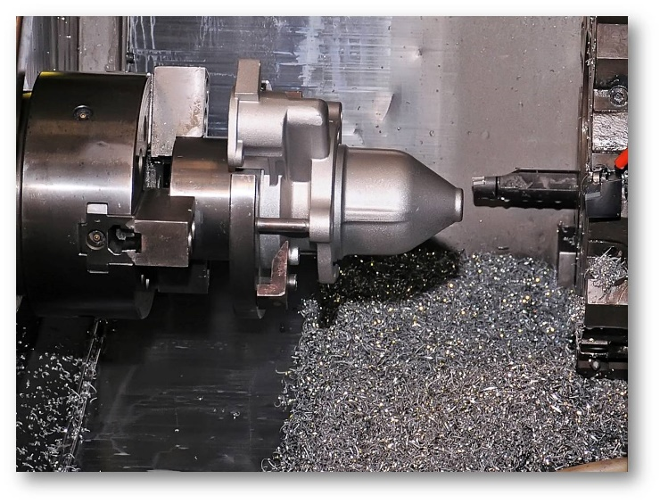

* **CNC AUTO LATHE**

In CNC auto lathe the turning operation is performed. In turning, carbide or ceramic cutting tools are used to create a smooth finish on the casting. These tools have good wearability, with long life and repeatability.

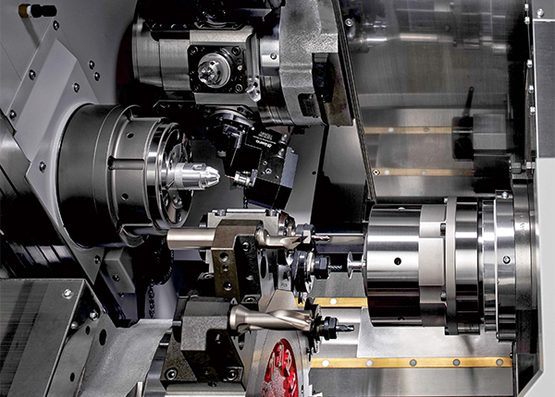

The component is positioned in a chucking (turning) fixture and rotated using either a vertical or horizontal machine. Using the tools, any unwanted material can be removed from the inside and outside of the aluminium metal to produce turned bores (holes) and diameters to close tolerances, with a high standard of finish.

* **ROTARY DRILL & TAPING**

Rotary drilling is performed to create a smooth hole in the aluminium metal with a drill and motor.

Tapping is the action that creates the threads into the side of hole.  A tap is a cylindrical or conical thread-cutting tool having threads of a desired form on the periphery. Combining rotary motion with axial motion, the tap cuts or forms the internal thread.

**.**

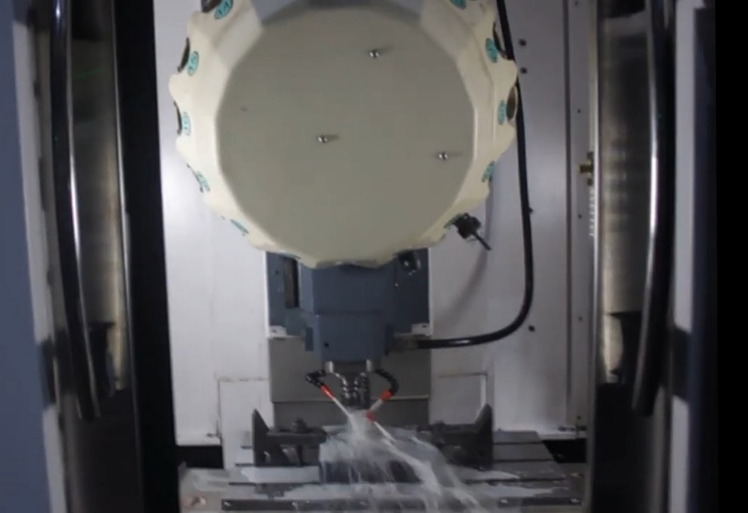

* **SHOT BLASTING**

After completion of fettling, shot blasting is performed. Shot blasting is a mechanical [Surface treatment](https://www.investmentcastingpci.com/stainless-steel-casting-surface-treatments/) process. In the investment casting process, Shot blasting is a post-production finishing service. It is processed by the rapid impact on the surface of investment castings with an abrasive material. Its purpose is to remove various impurities from different surfaces.

Shot blasting is to remove the surface oxide and other impurities to improve the appearance quality and shot blasting makes the surface of the work piece reach a certain degree of roughness. Make the workpiece beautiful, or change the welding tensile stress of the workpiece to compressive stress and improve the service life of the workpiece.

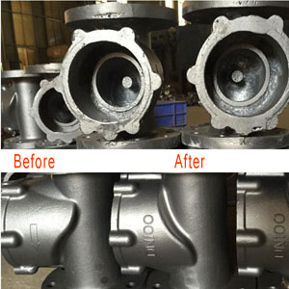

Shot blasting is using the centrifugal force of the impeller on the throwing head of the shot blasting machine at high speed. Then to shoot the abrasive at a very high linear velocity on the surface of the treated steel to produce a striking and grinding action to remove the oxide scale on the steel surface and rust.

ULTRASONIC CLEANING

Cleaning of casting material is very important in manufacturing industry. It is major problem because of life of casting decreases and roughness. So, it is necessary to clean the casting metal. The cleaning is done by using ultrasonic cleaning machine. Ultrasonic cleaning uses high-frequency, high-intensity sound waves transmitted through the liquid to enhance the removal of foreign contaminants from surfaces submerged in an ultrasonically activated liquid. The frequency used is generally 30 kHz.

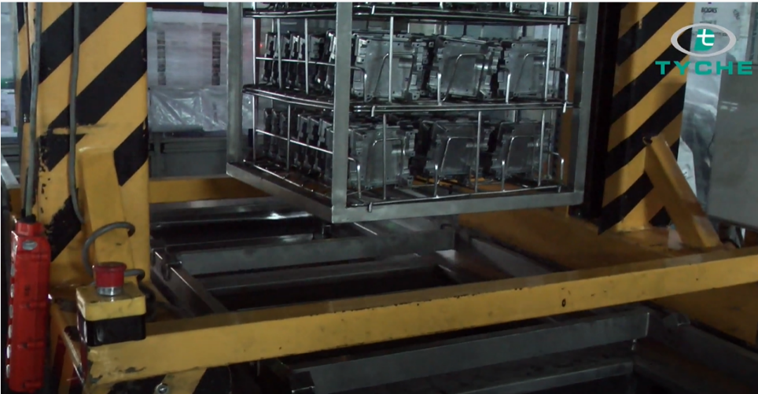

INSPECTION

Inspection of casting material plays a vital role. The inspection of casting material measures the geometry and detects the defects, if occurred during the casting process. The inspection of aluminum metal is performed by using various machines like

* Coordinate measuring machine (CMM).
* Profile projector.
* Universal testing machine (UTM).
* X-ray

CMM MACHINE

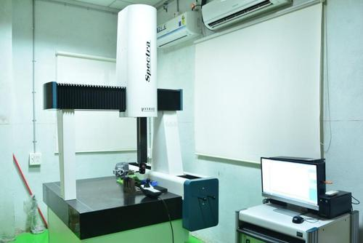

CMM machine measures the physical geometry characteristics of aluminum metal. It measures the geometry of a metal with high accuracy of 0.001mm and controlled by a computer. It uses a probe to measure the metal. The primary application of CMM machine is inspection. Since, its function is driven by an onboard computer it can be easily integrated into a computer integrated manufacturing environment. It offers flexibility and multiple features.

PROFILE PROJECTOR

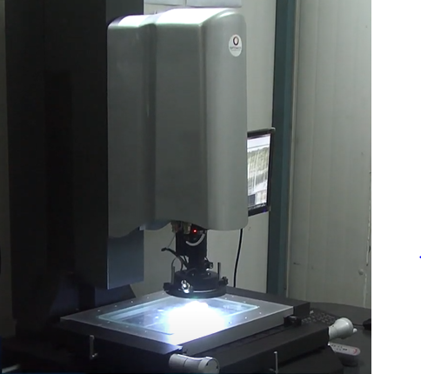

Profile projector projects a magnified profile image of an are or feature of aluminum metal. Project profile measure the dimensions of casting meterial with high accuracy. The defects like scratches and dents of casting material can be easily magnified using this profile projector.

UTM MACHINE

Universal testing machine is used to inspect or test the tensile and compressive test of casting material.

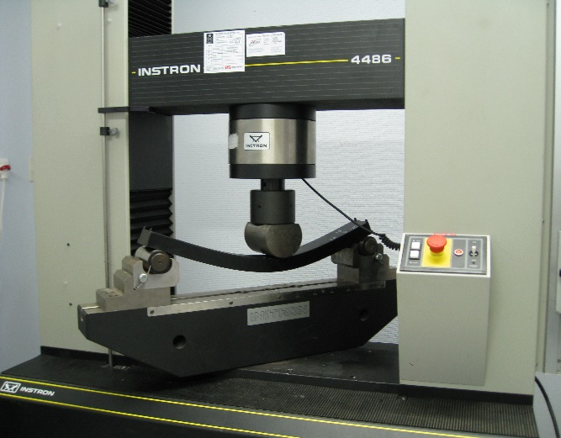

X-RAY TESTING

X-Ray testing is the best non-destructive inspection method for detecting internal defects of castings. In this method, a casting is exposed to radiation from an x-ray tube. The casting absorbs part of the radiation, and the remaining portion of the radiation exposes the radiographic film.

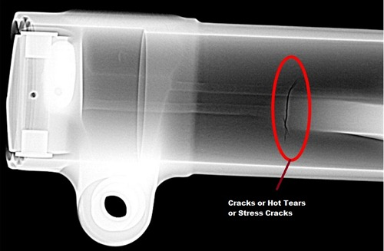

DISPATCH

The product is packed and supplied to the customer after completing all the inspection and trails with best assurance.

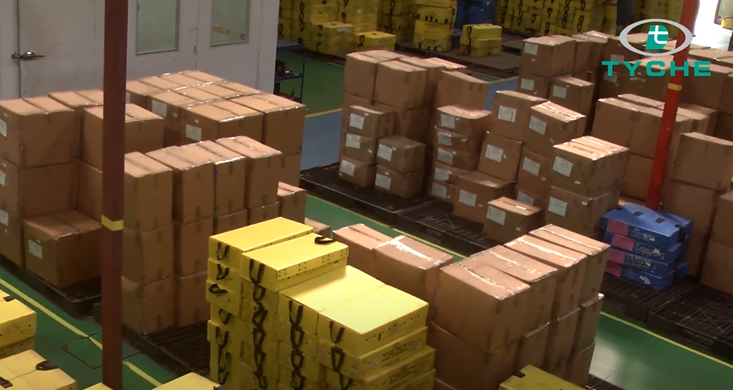

**CONCLUSION:**

The internship program at EQIC DIES & MOLDS Engineers Pvt.Ltd, especially in the Dies and Moulds division under the guidance of Mr. Nitin and Mr.Akhil, has helped us in ways beyond definition. Pursuing internship at an organization like EQIC DIES was a time well spent and utilized as weI came to learn and observe the different aspects of the die making process.

It was a pleasant experience finally to see the principles of production technique, metrology and workshop that we had learnt in our courses during our college.

It was a great learning experience and a time well spent where we observed and worked with Industry’s leading professionals.

**REFRENCES:**

<https://en.wikipedia.org/wiki/Die_(manufacturing)>

<http://www.diemakersmfg.com/>

<https://www.slideshare.net>

<https://www.goodwin.edu>

<https://www.sciencedirect.com/>

<https://monroeengineering.com/>